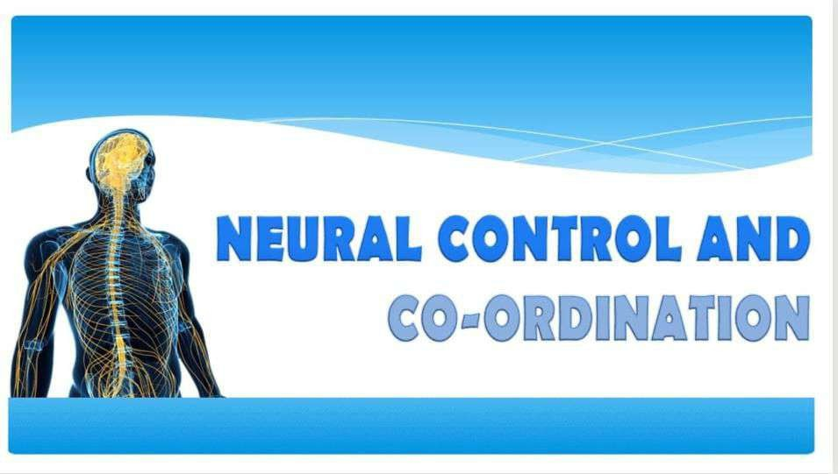

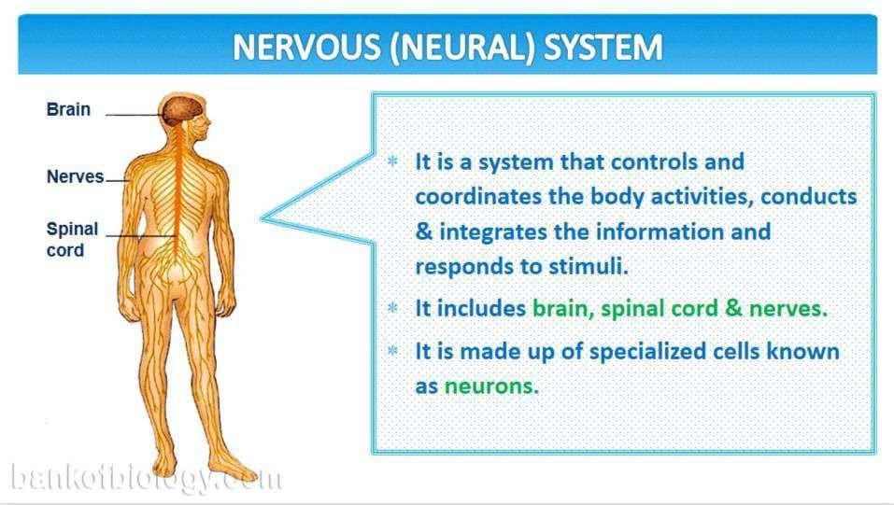

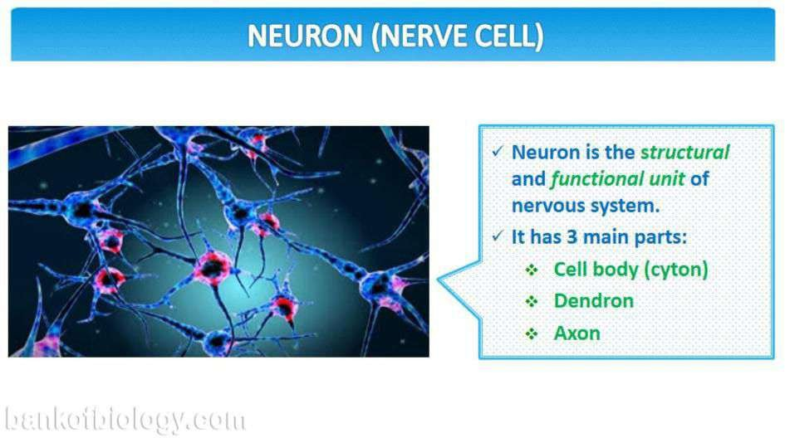

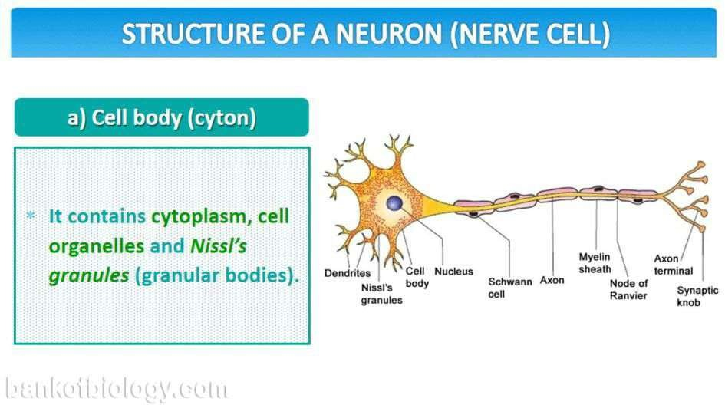

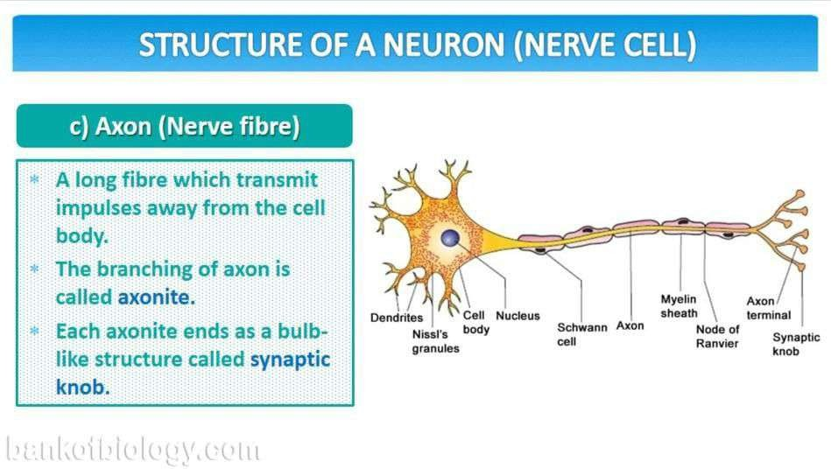

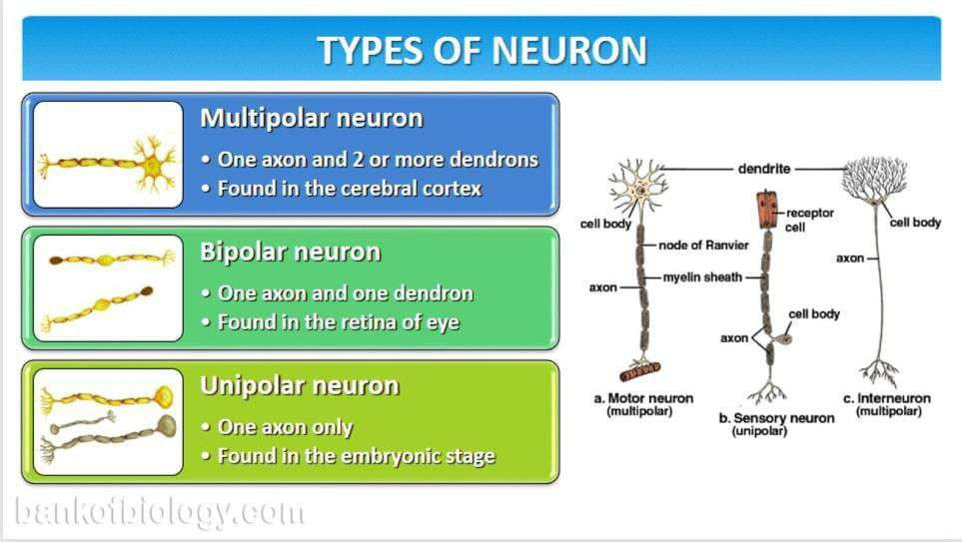

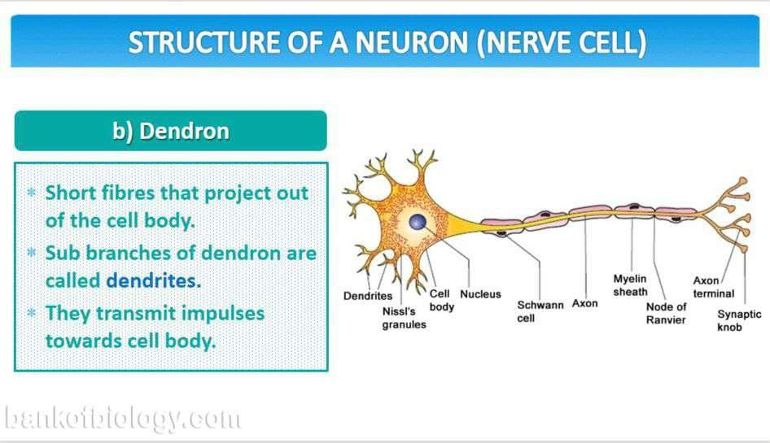

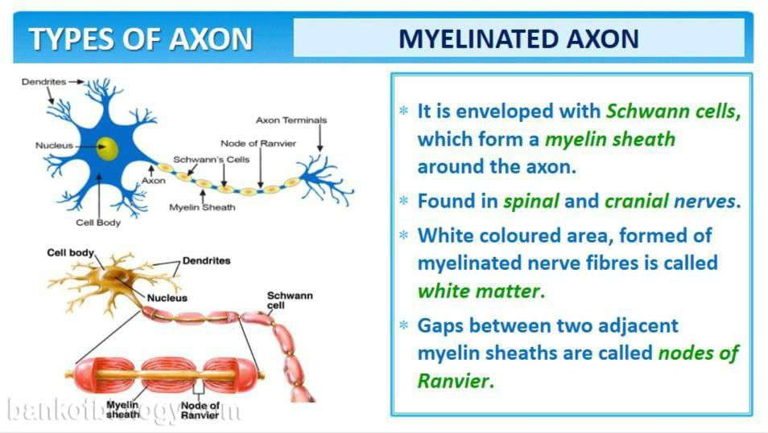

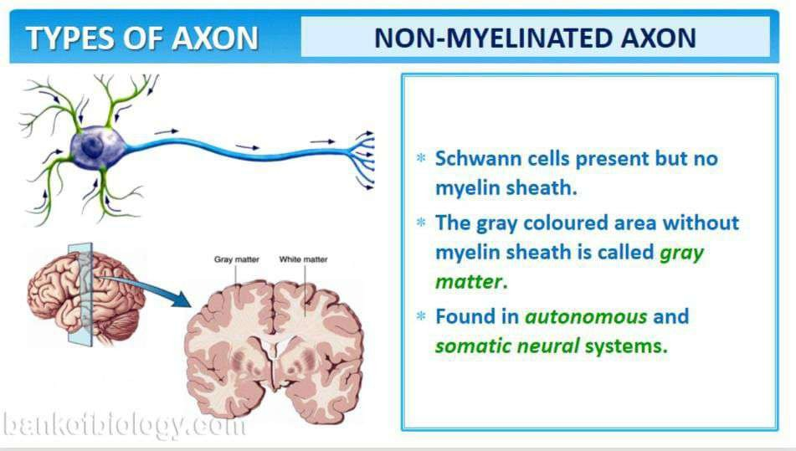

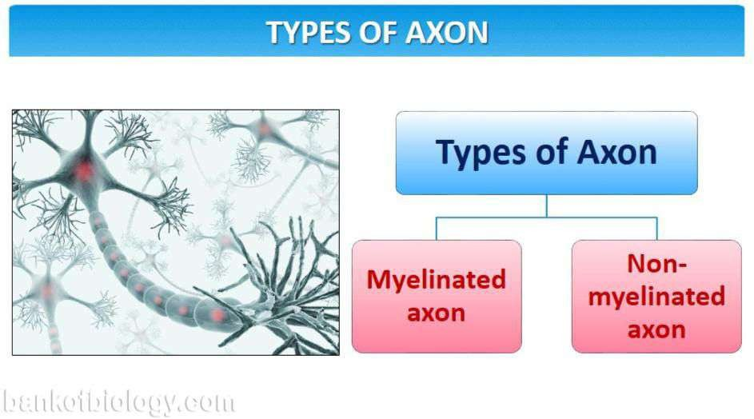

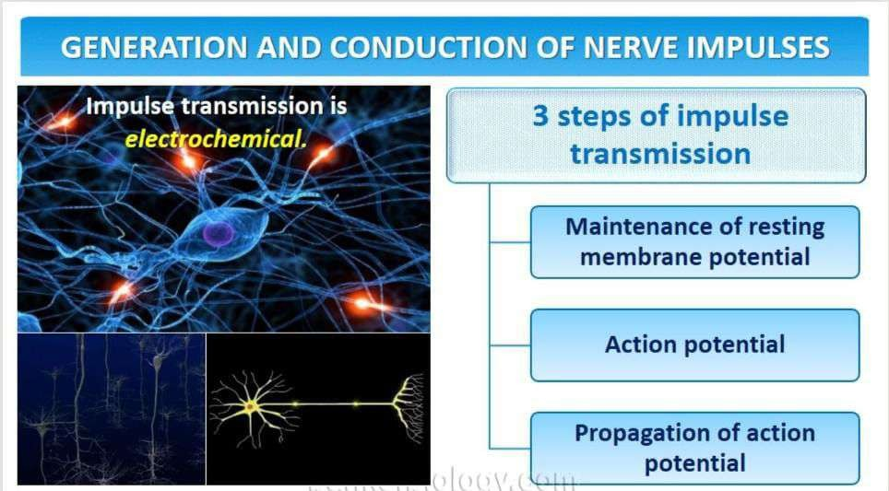

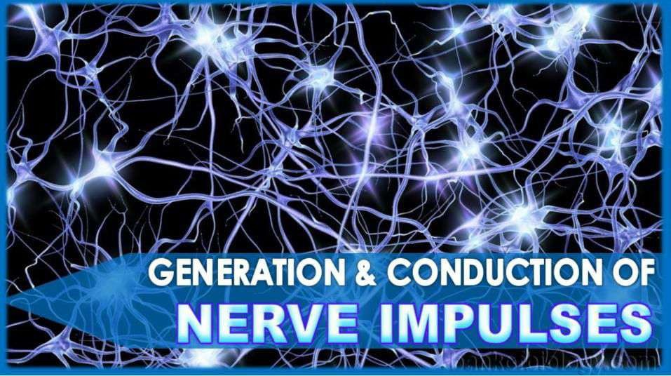

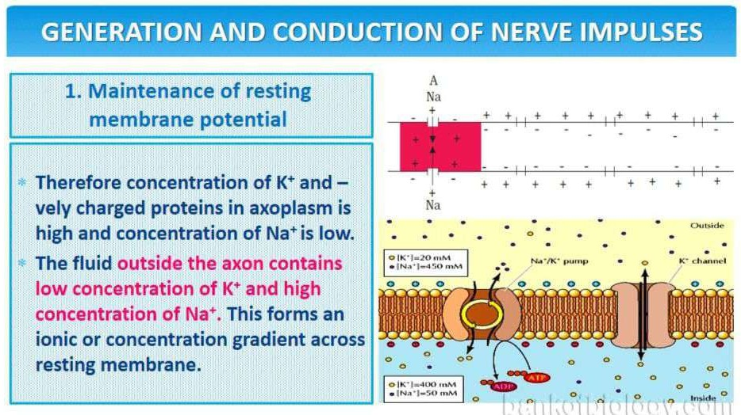

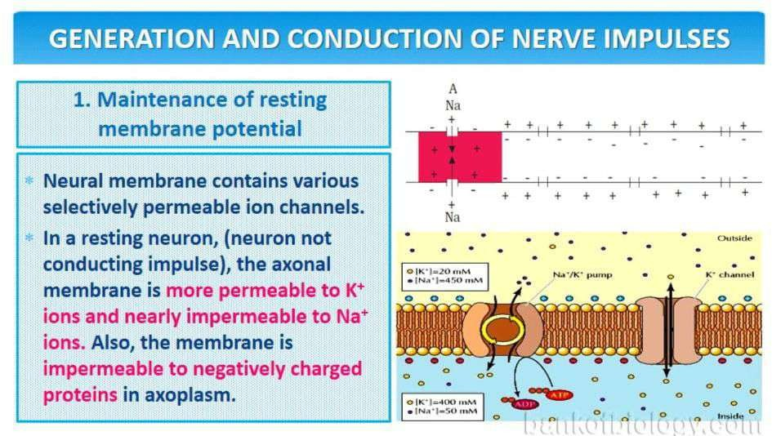

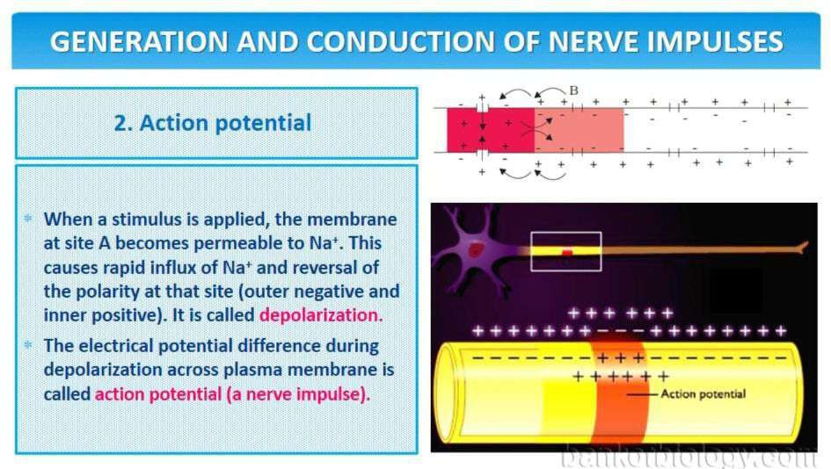

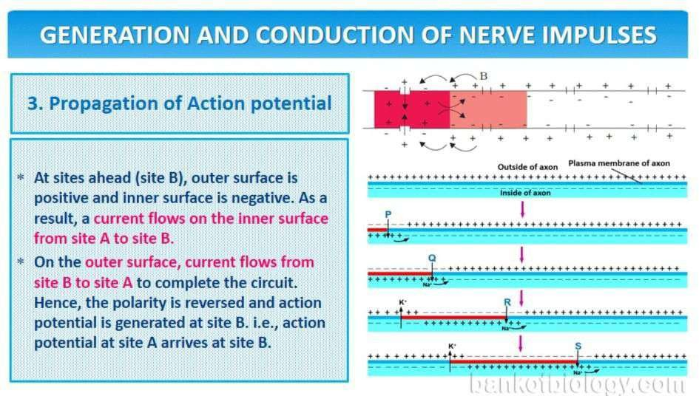

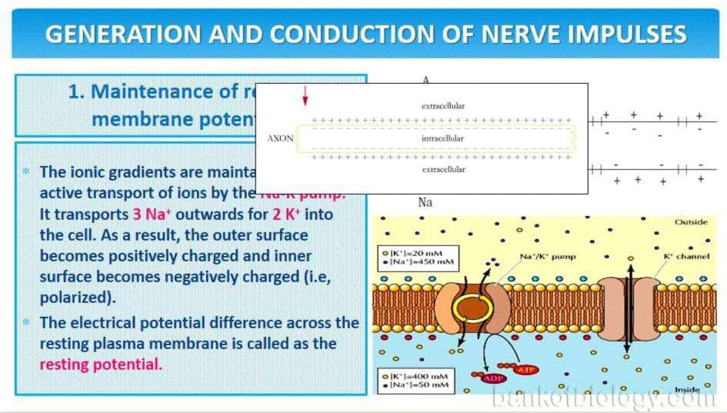

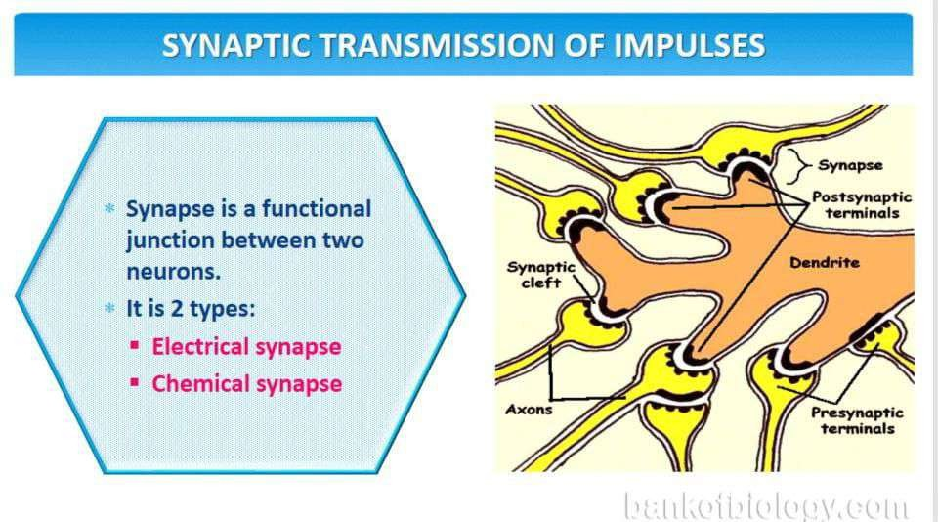

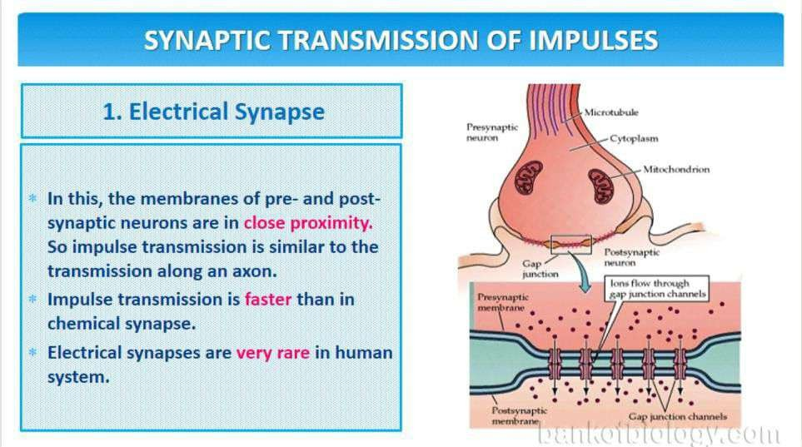

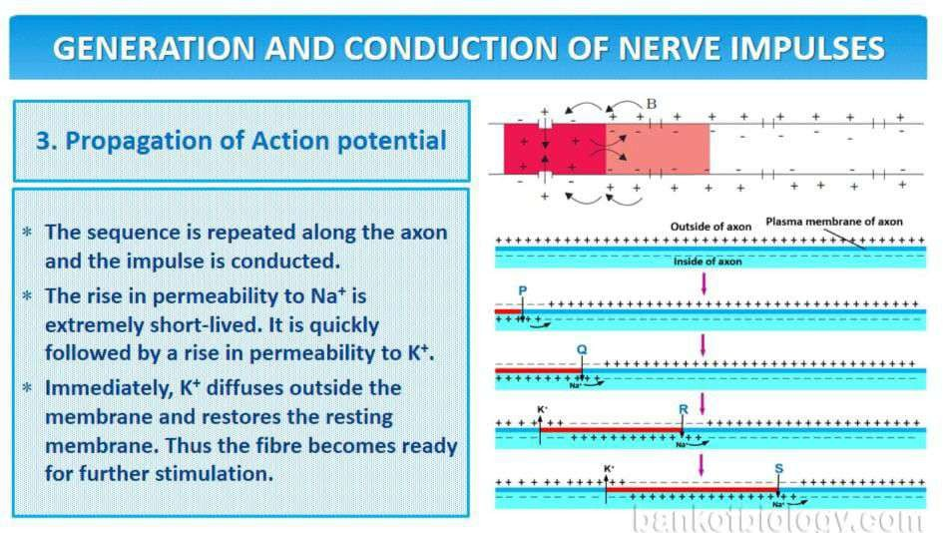

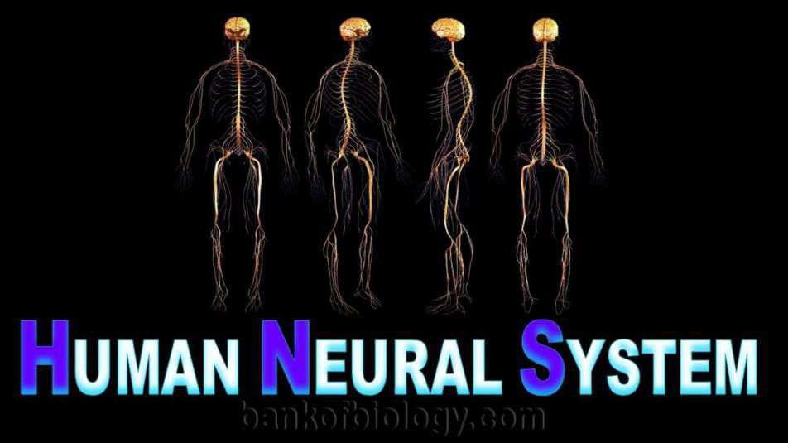

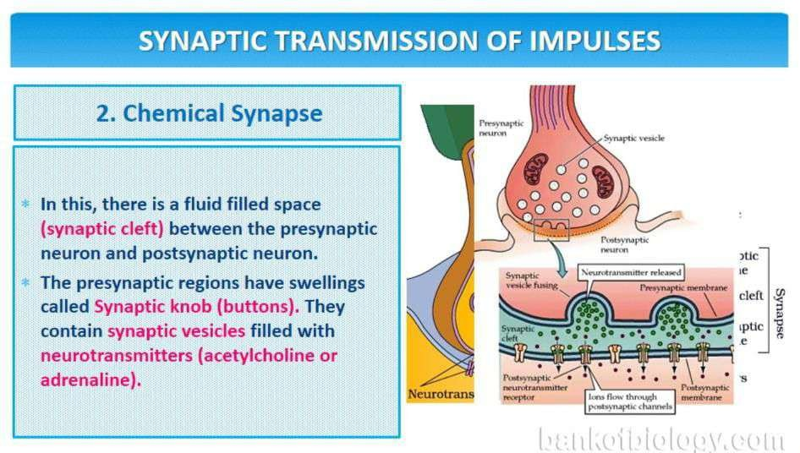

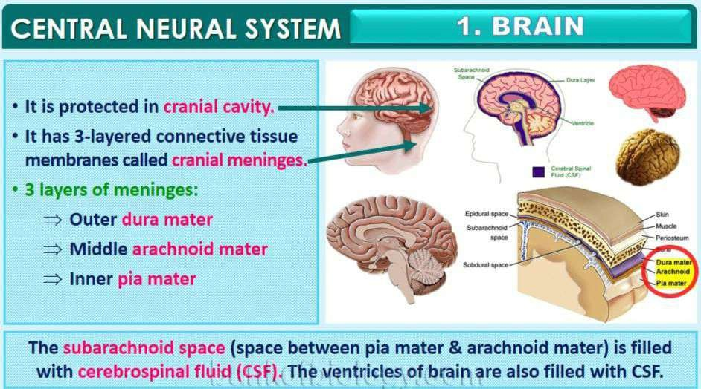

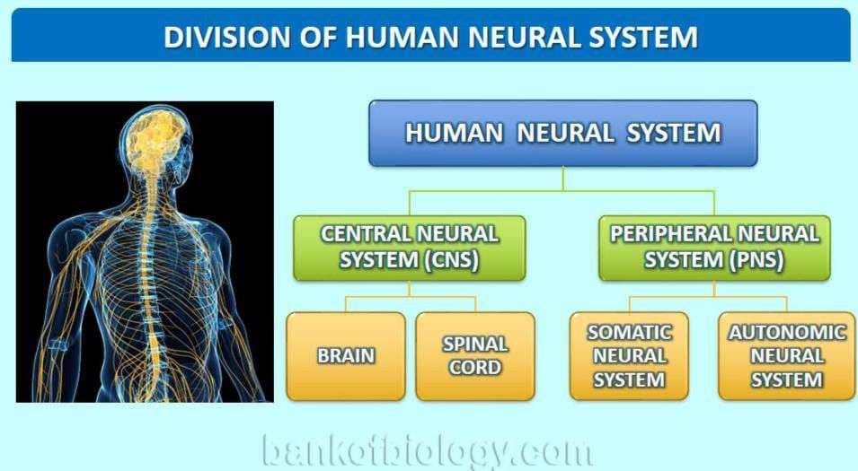

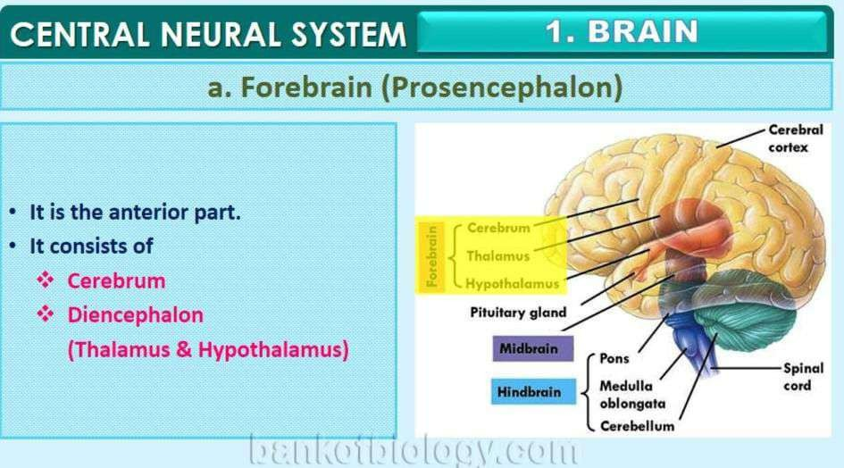

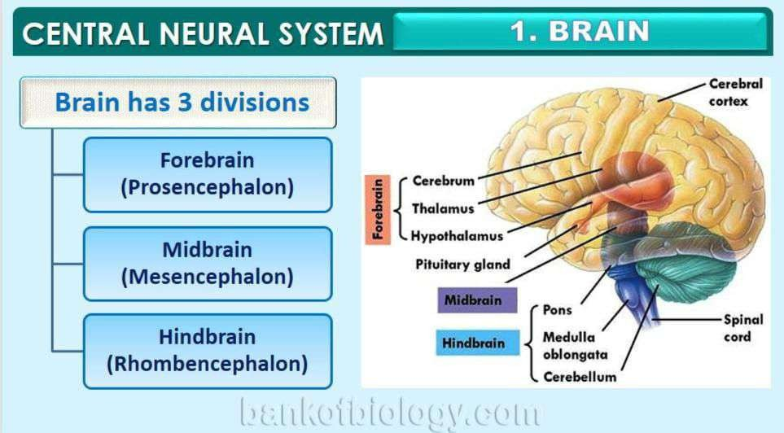

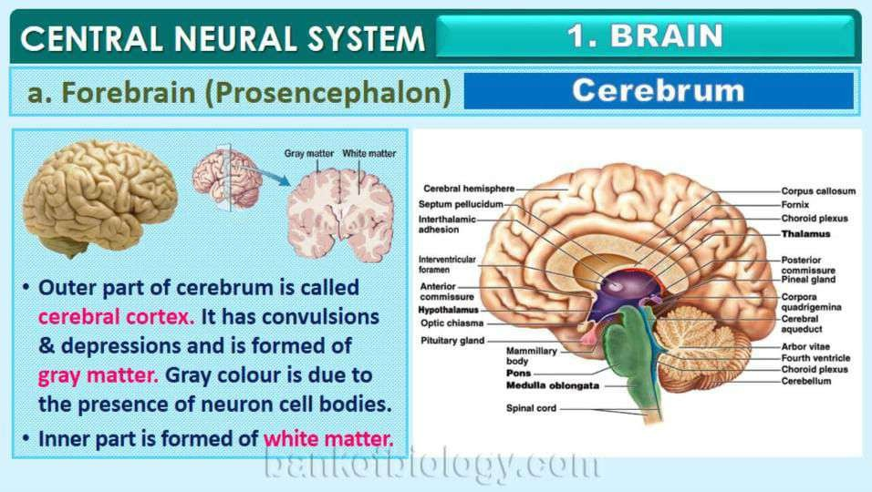

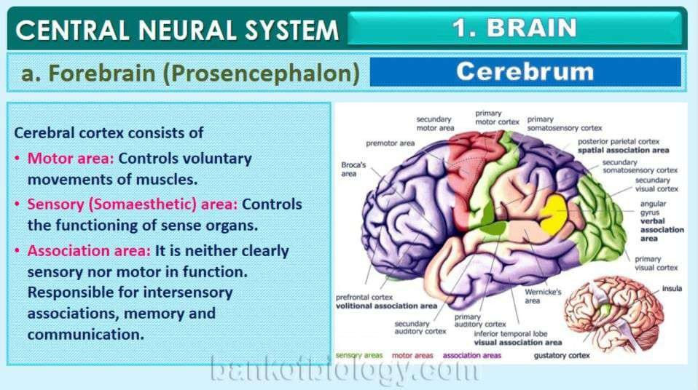

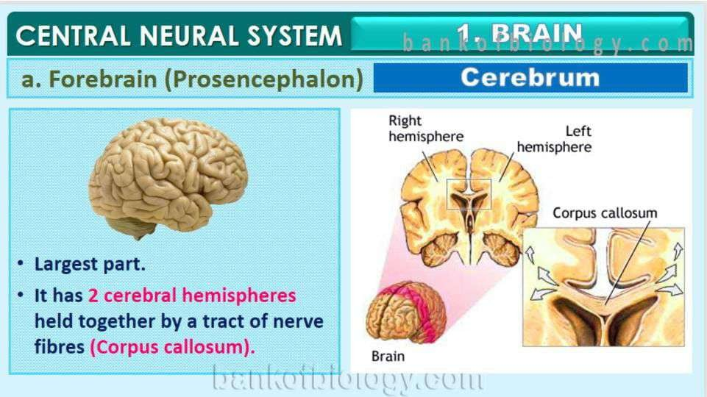

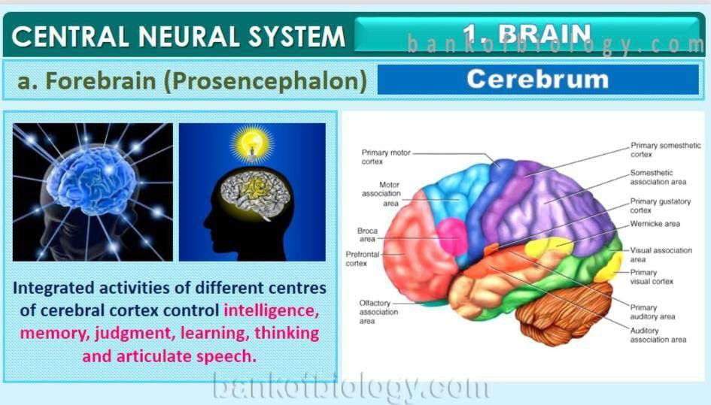

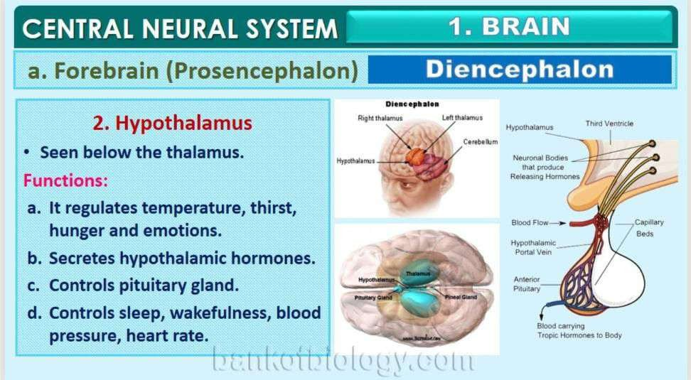

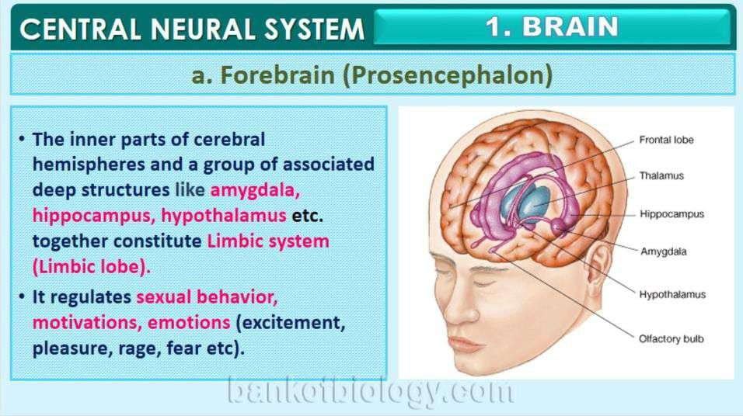

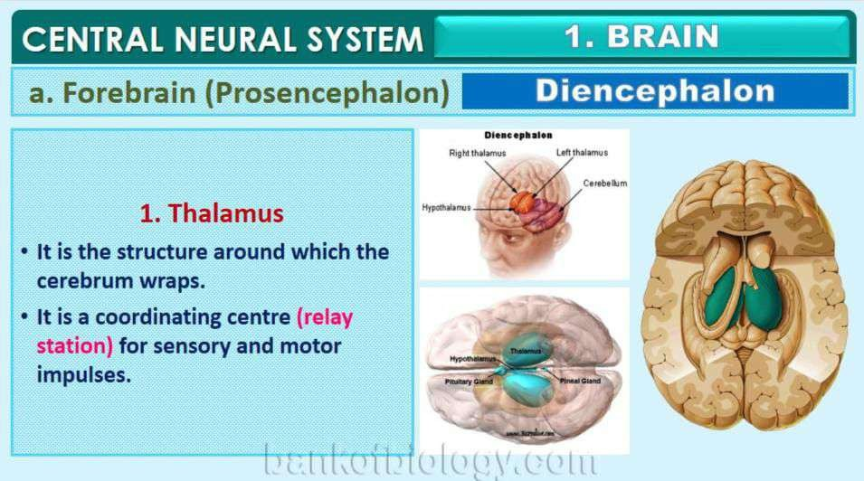

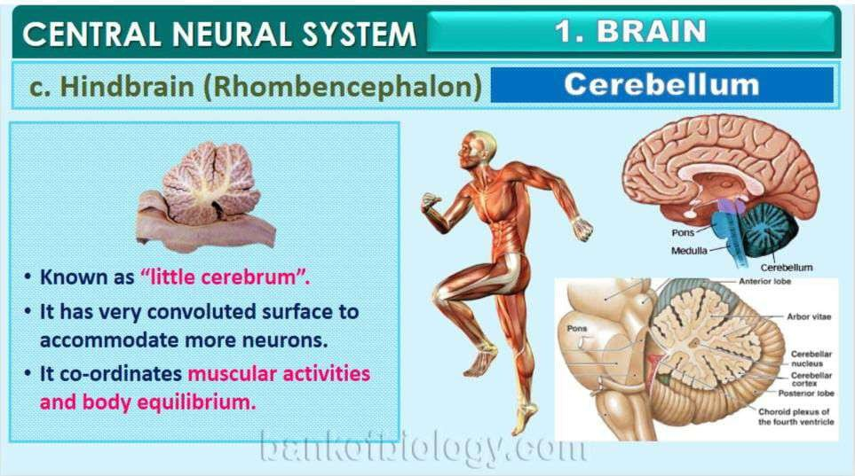

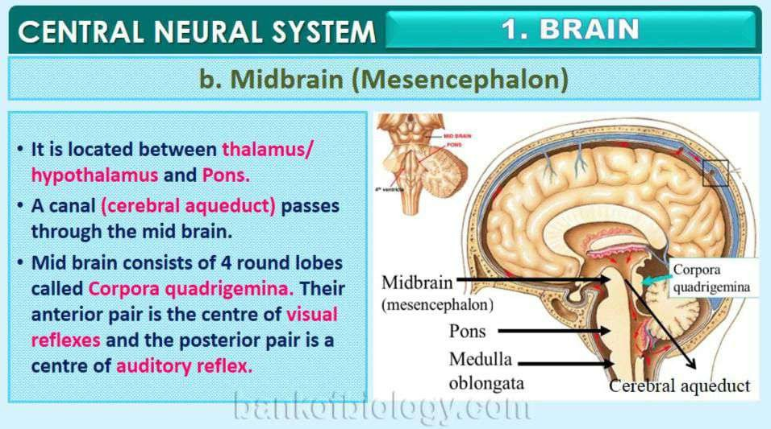

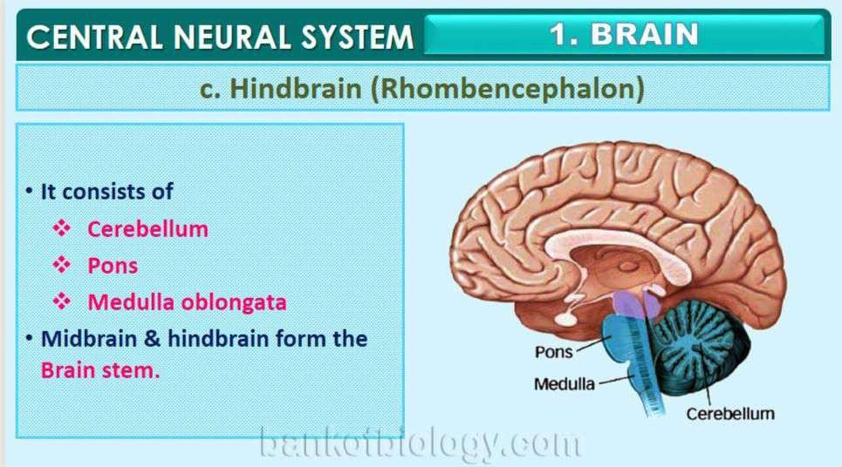

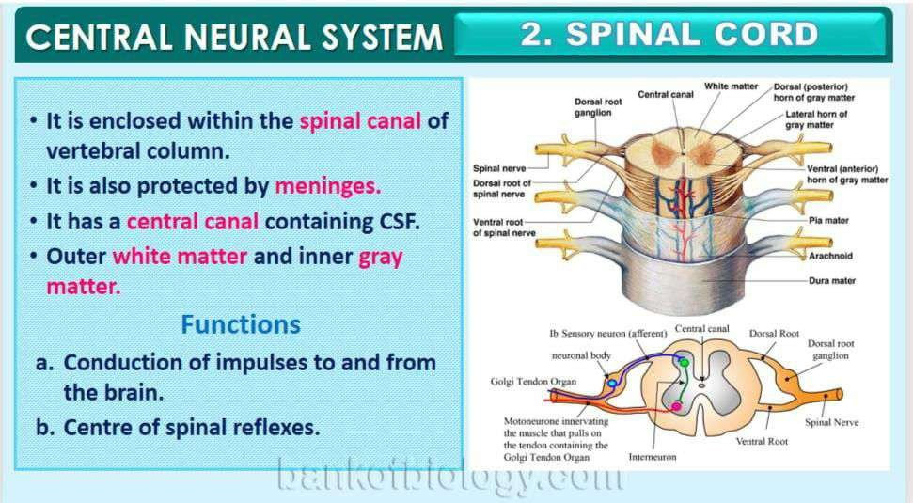

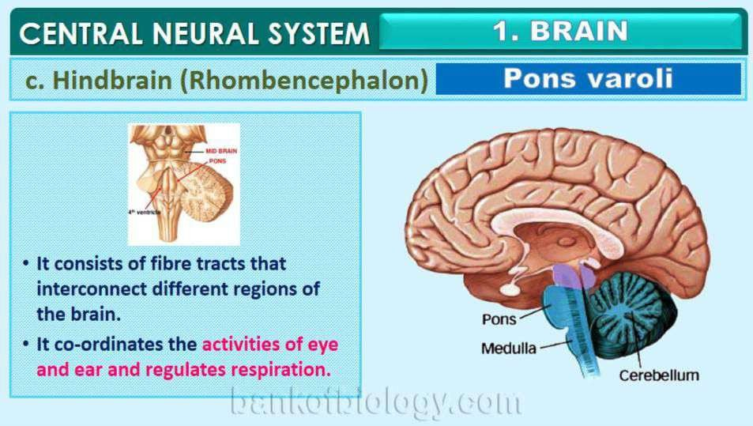

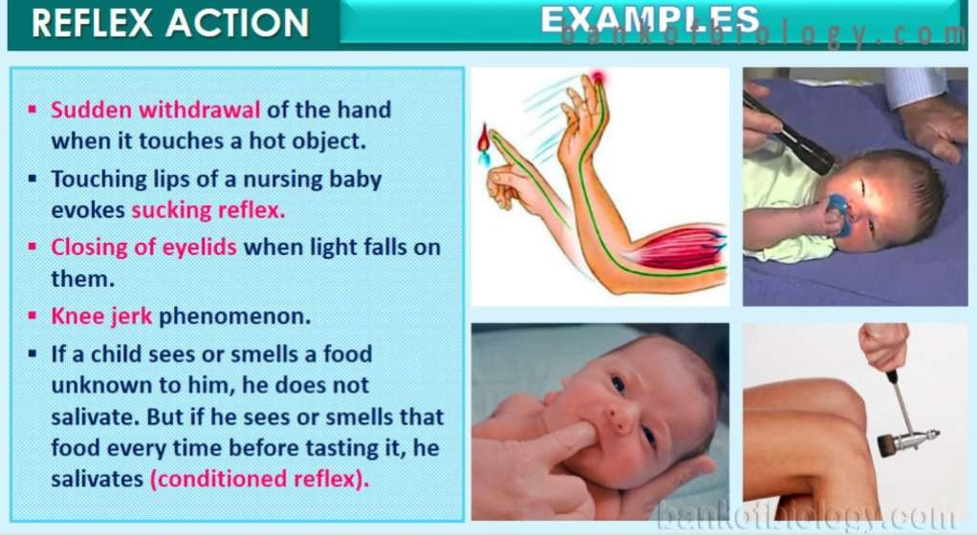

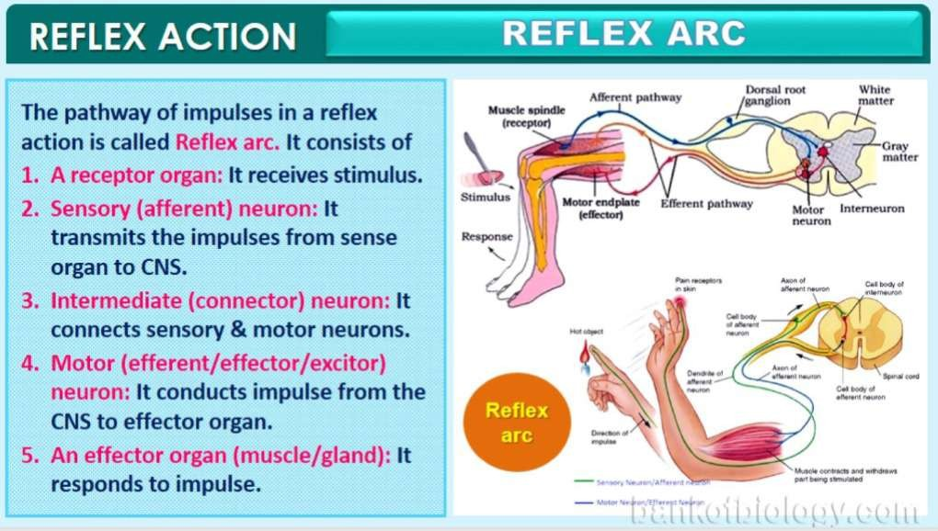

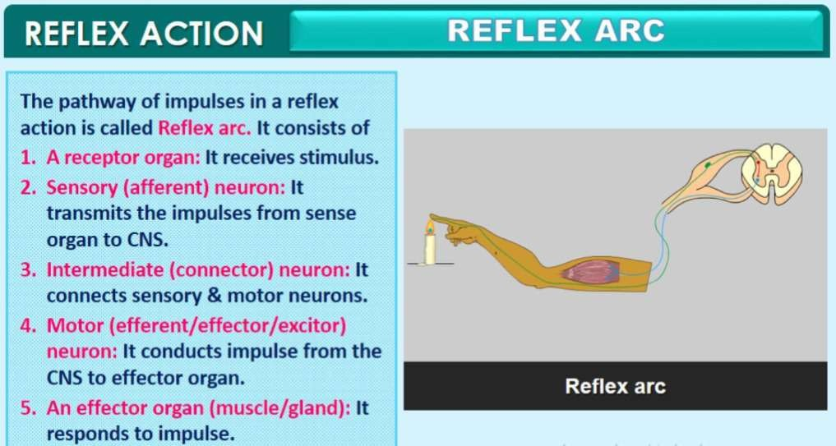

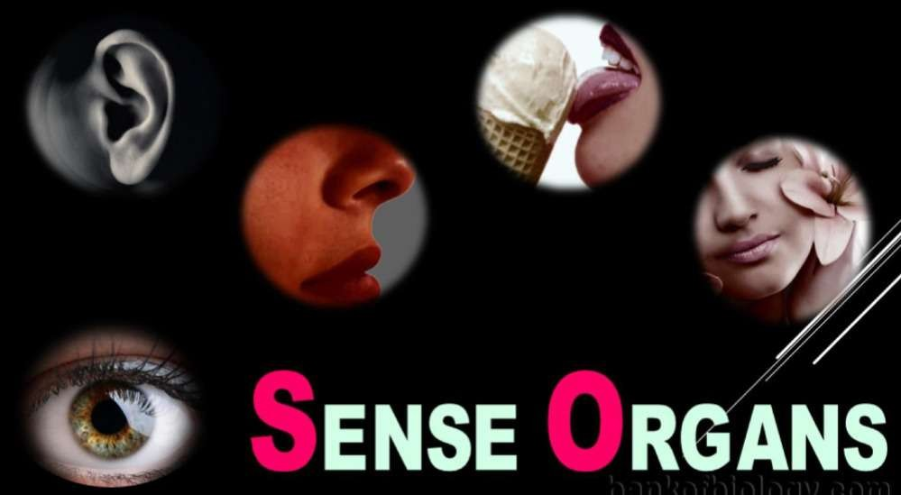

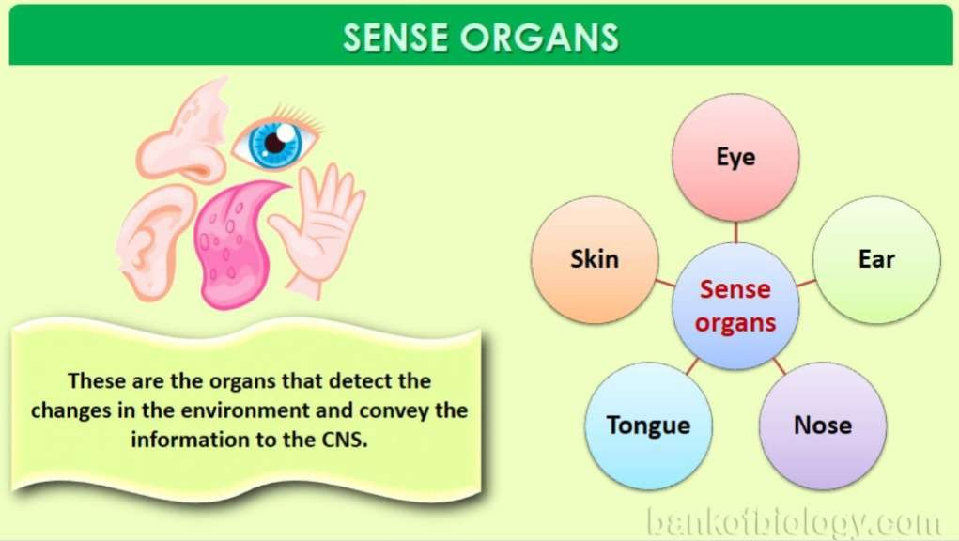

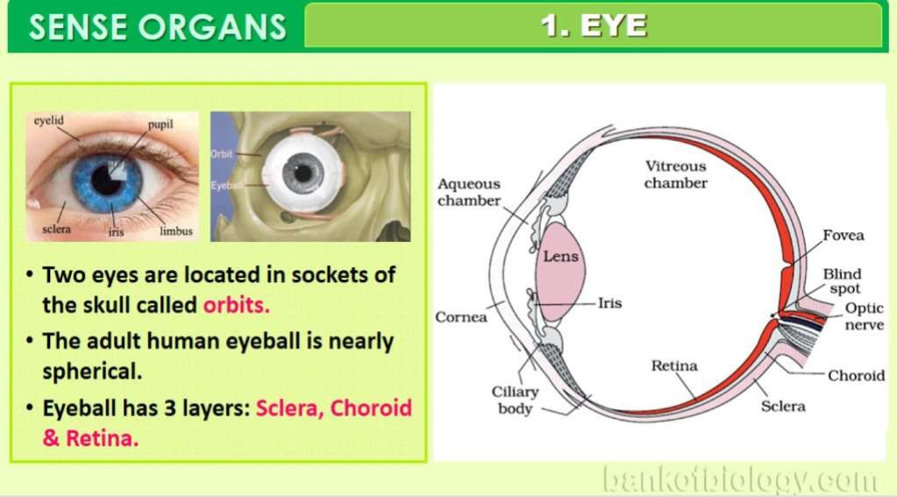

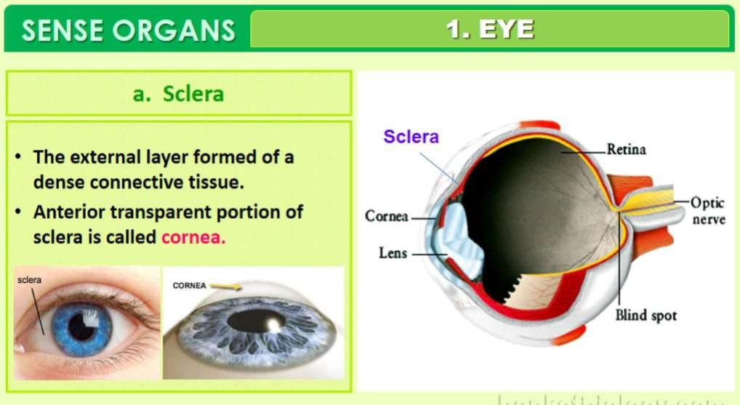

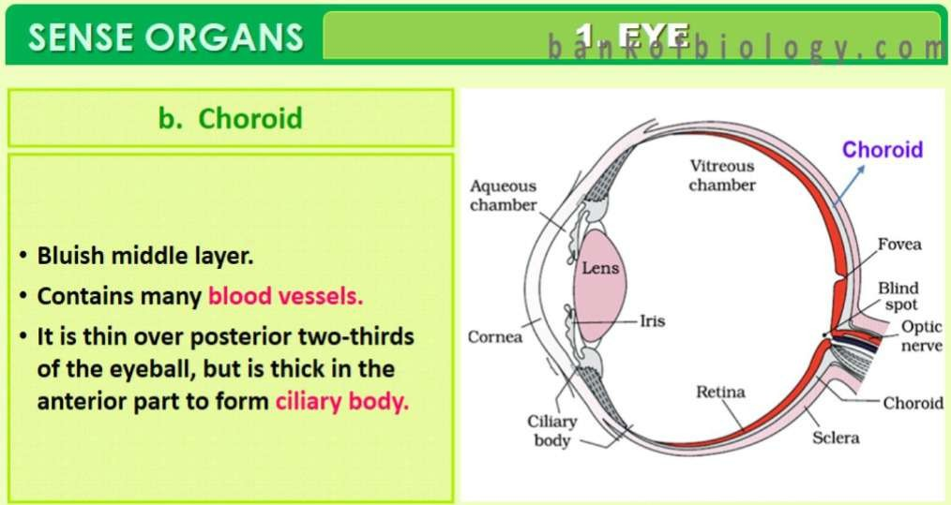

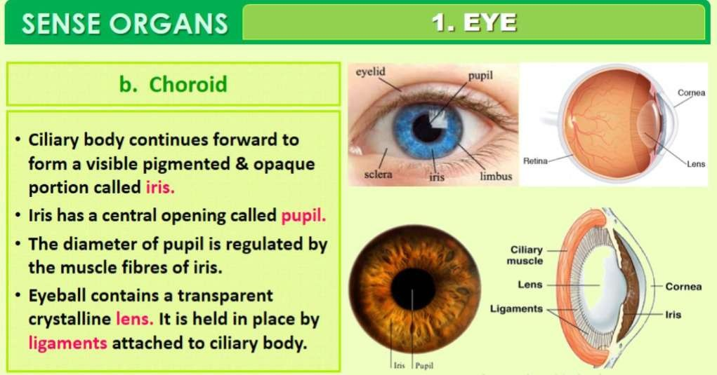

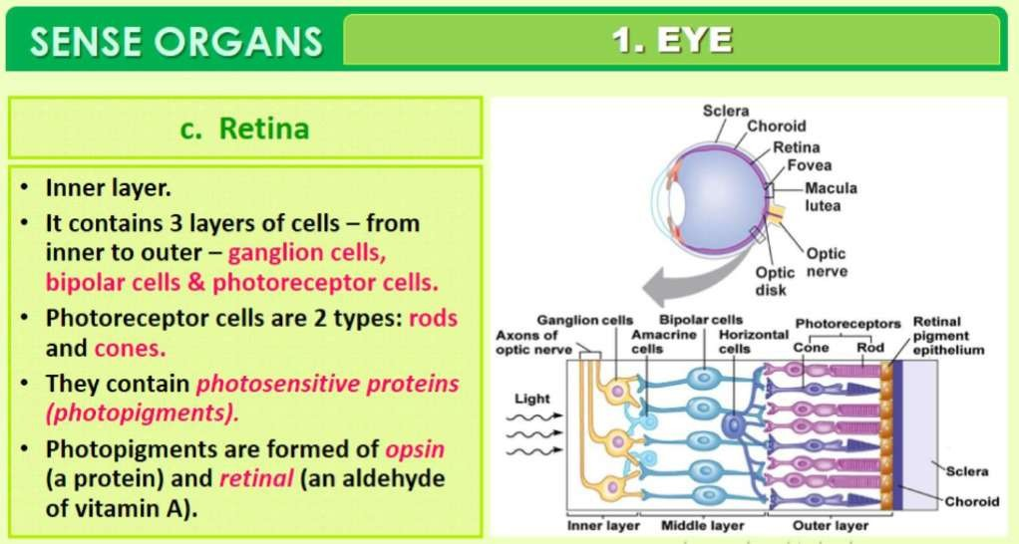

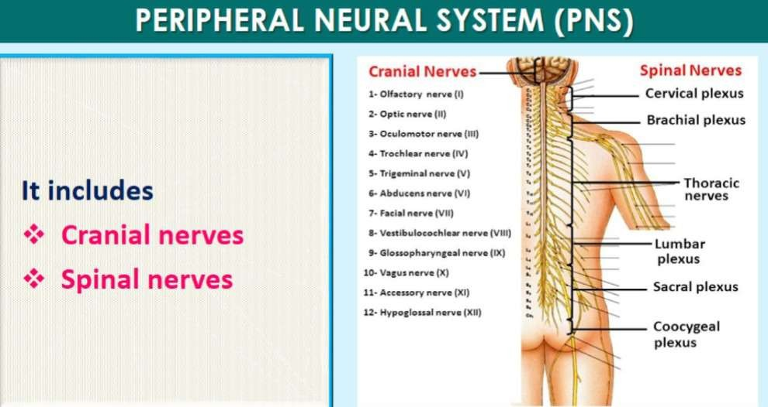

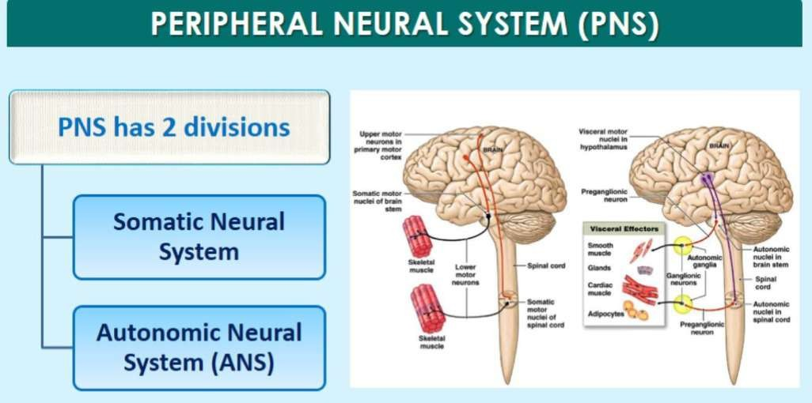

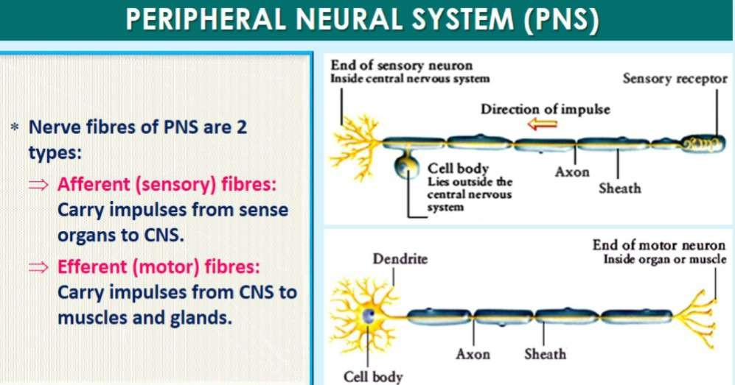

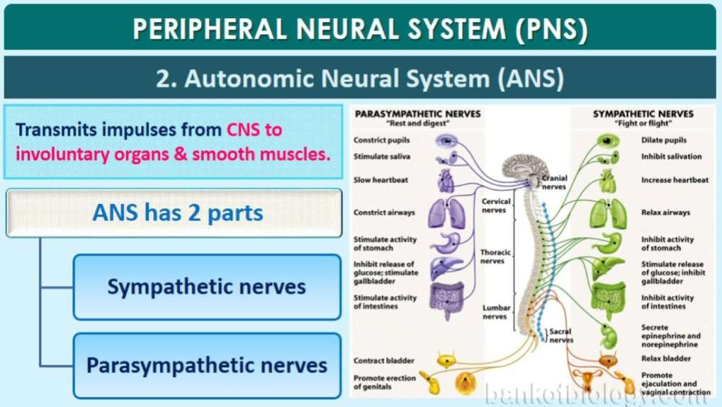

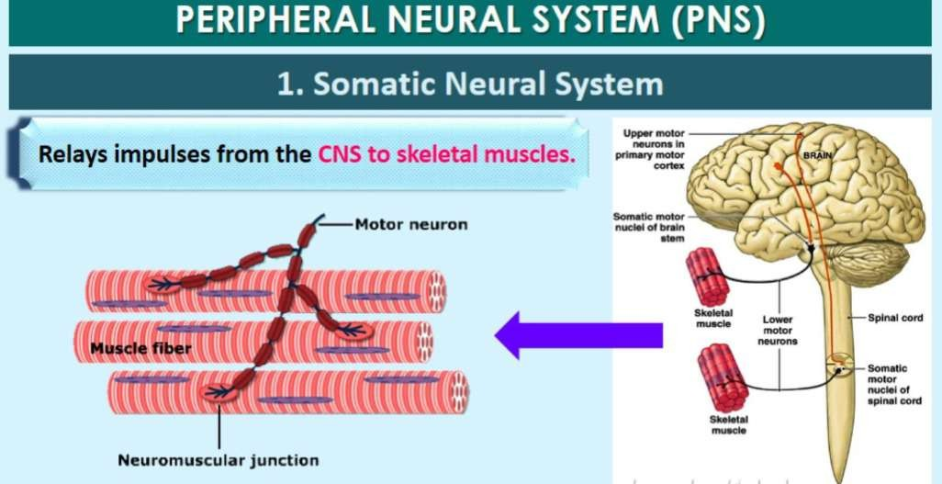

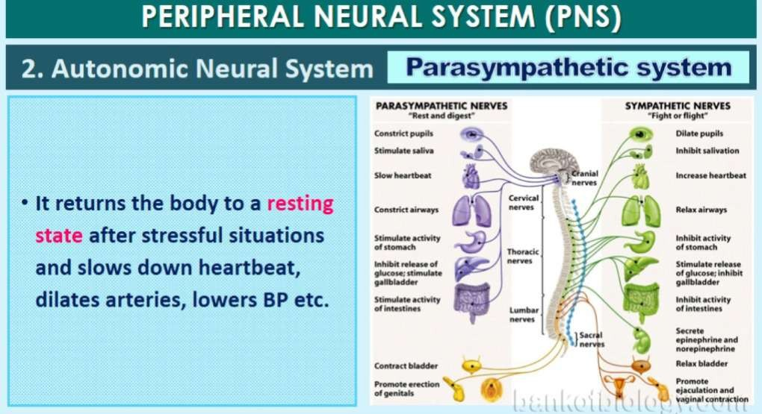

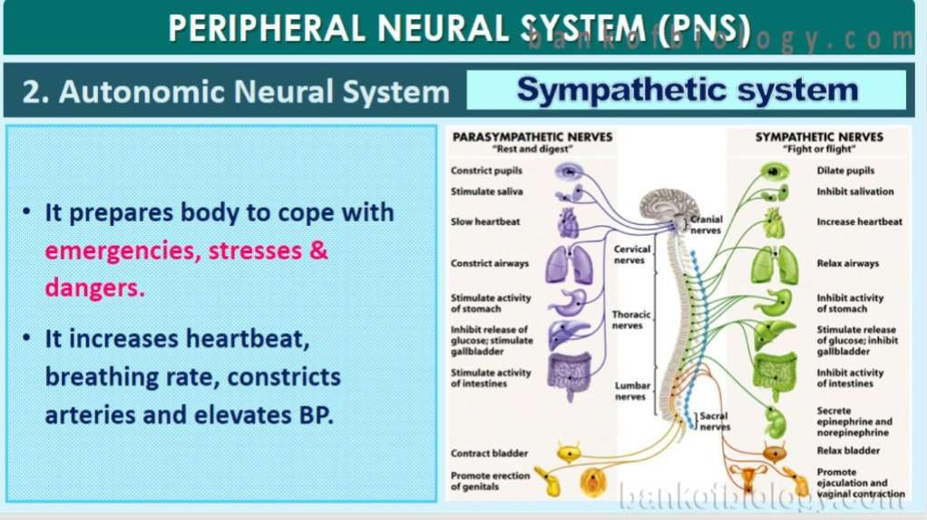

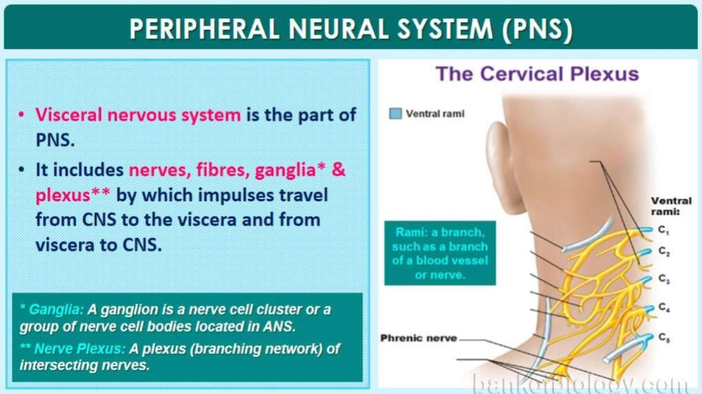

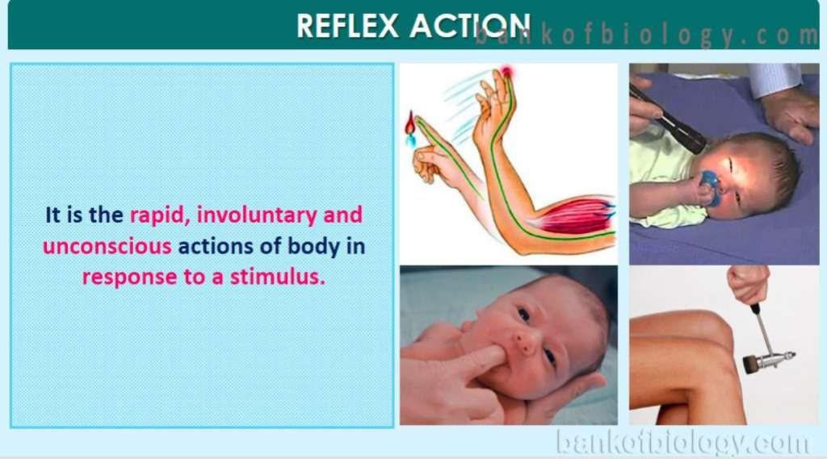

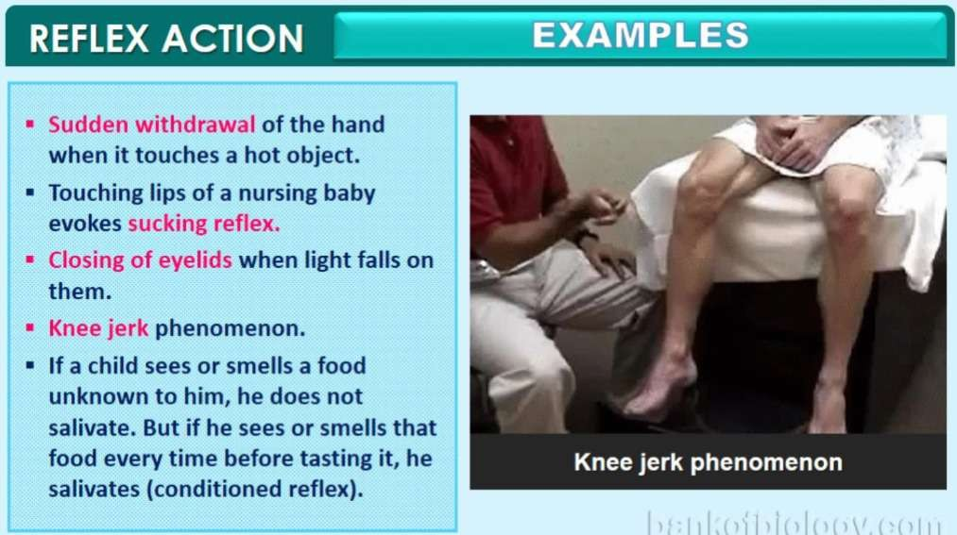

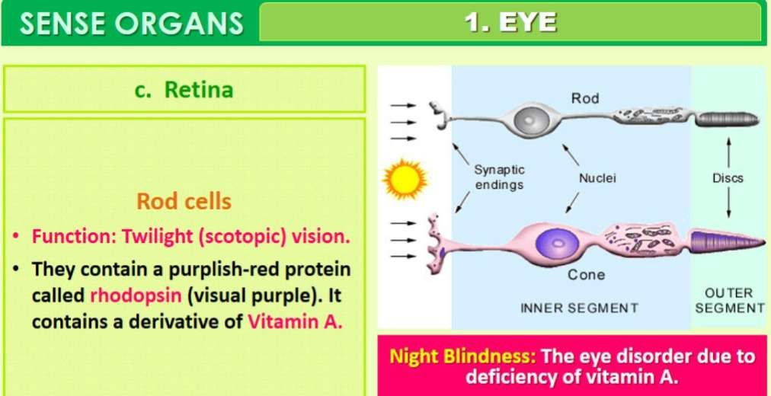

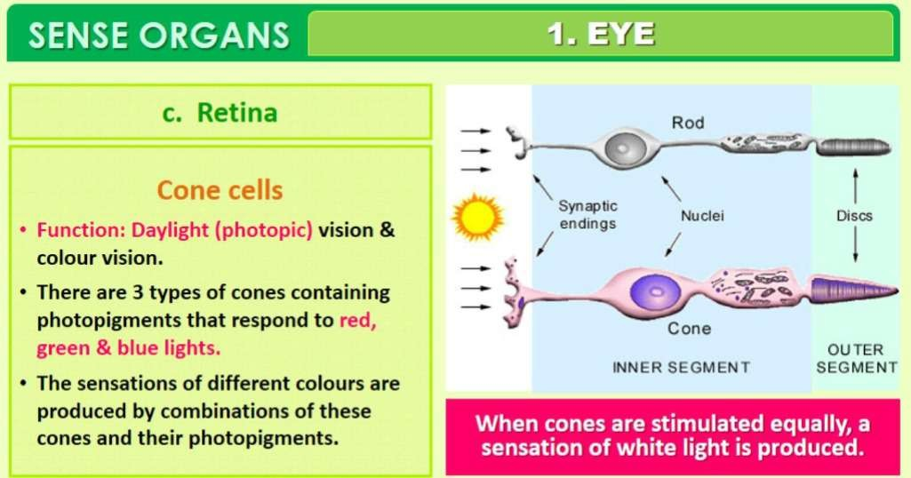

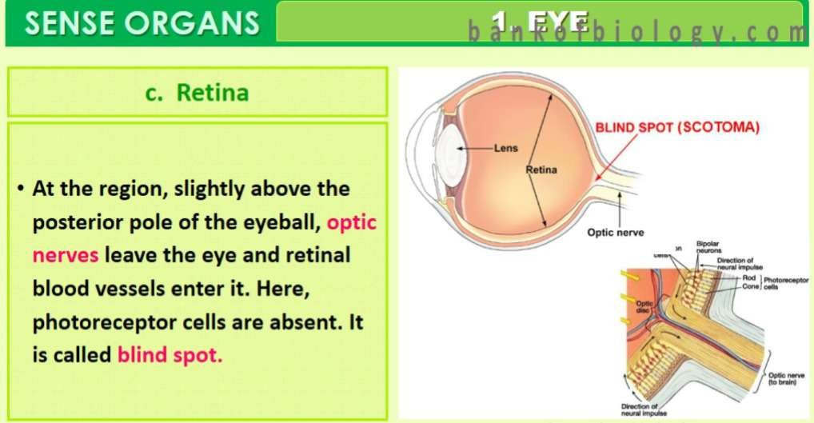

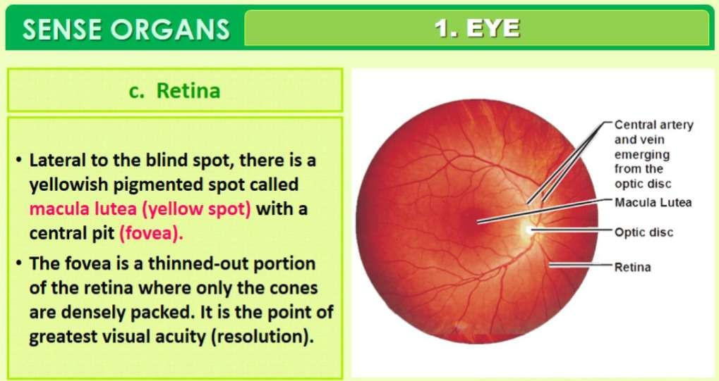

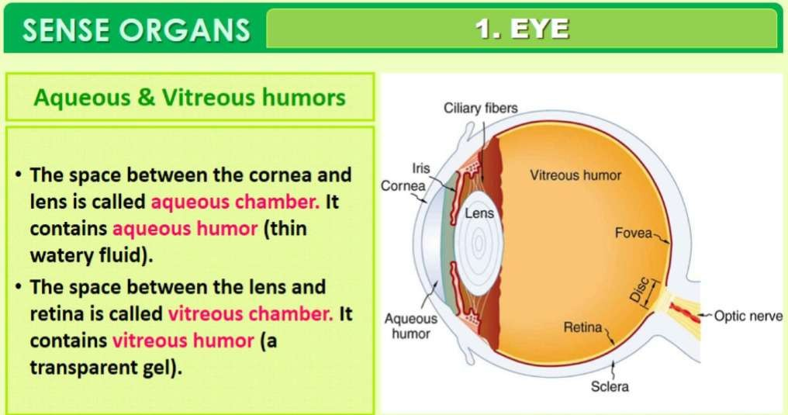

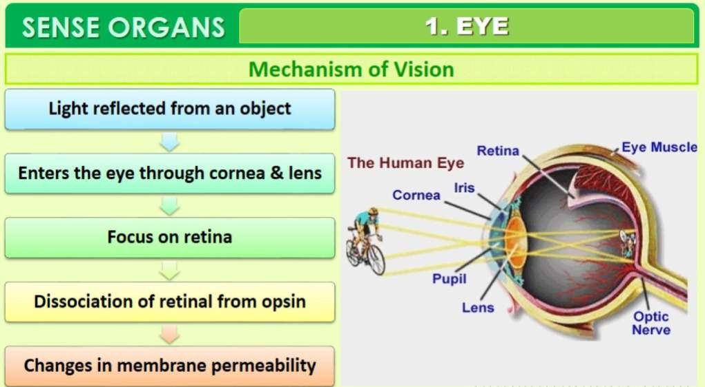

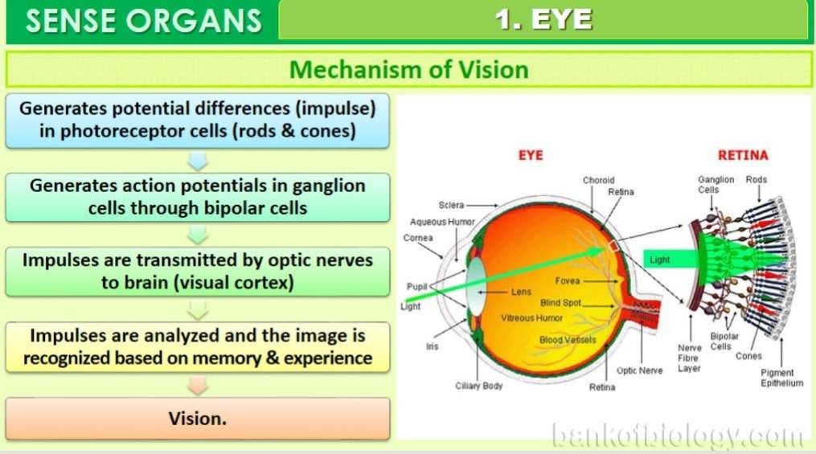

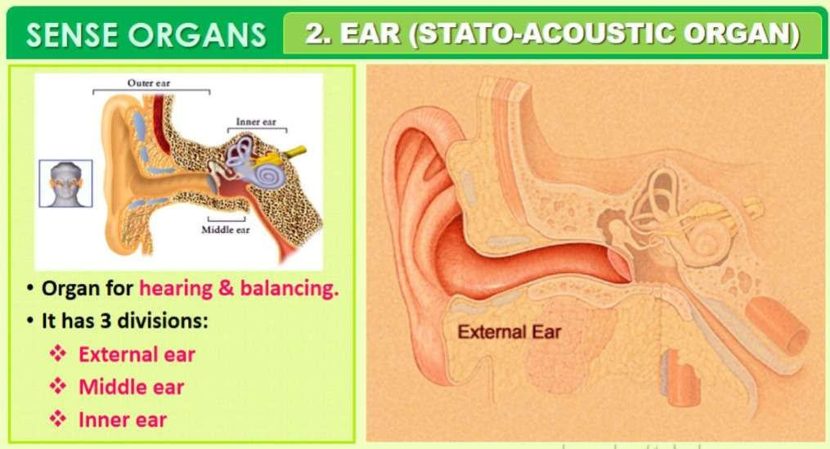

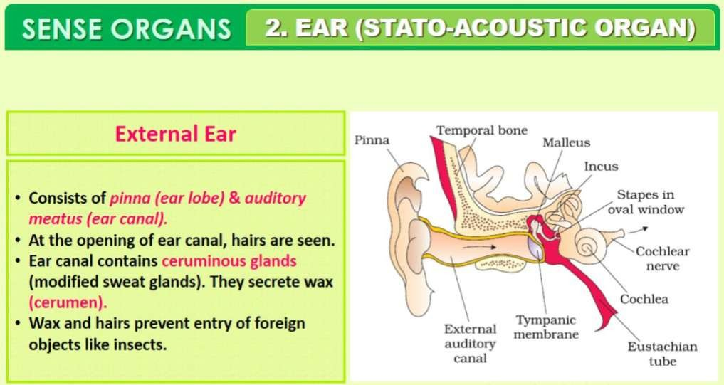

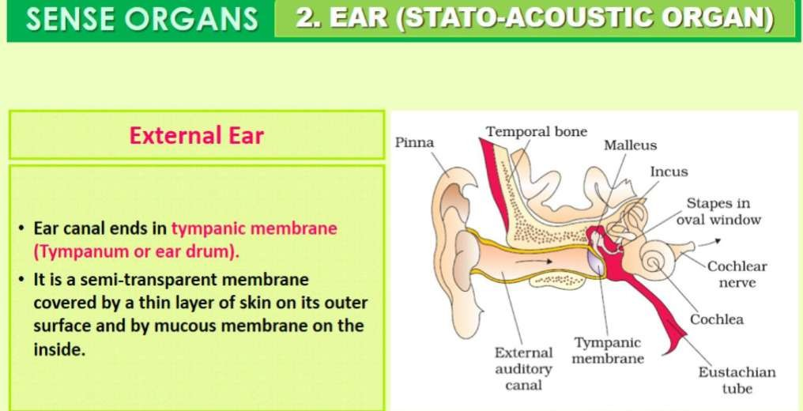

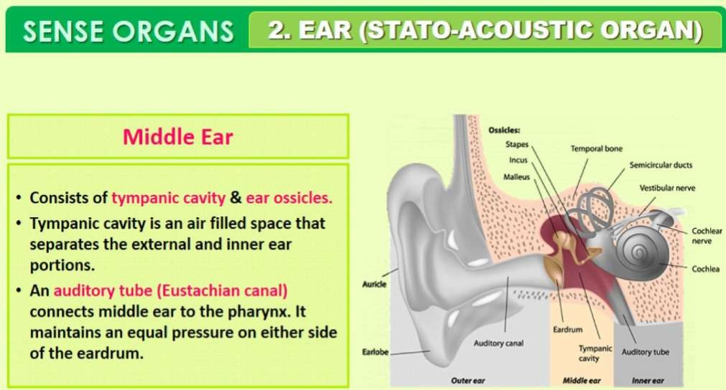

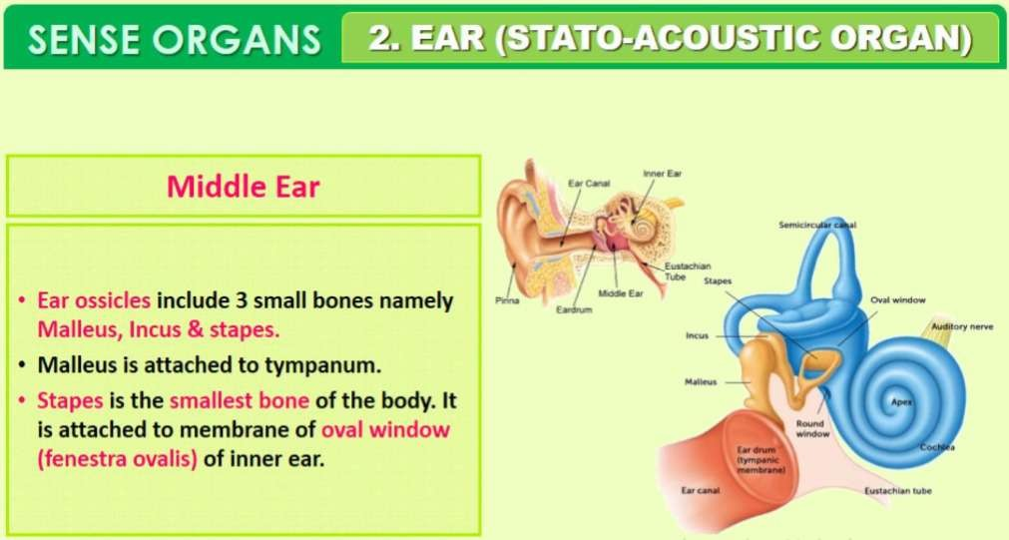

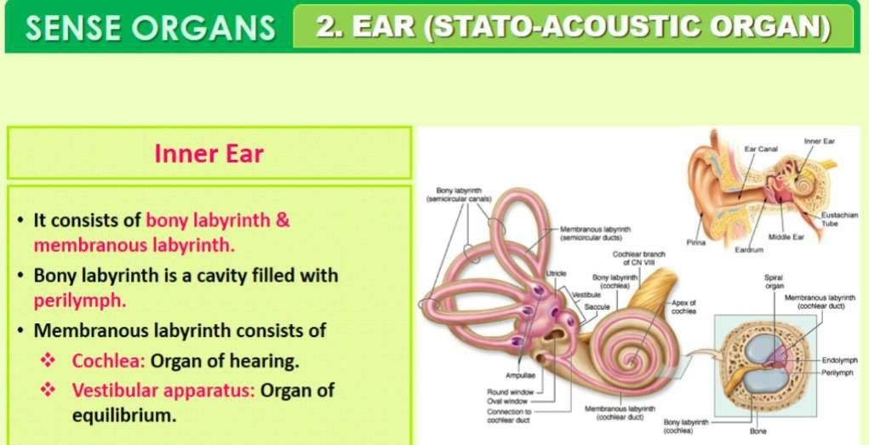

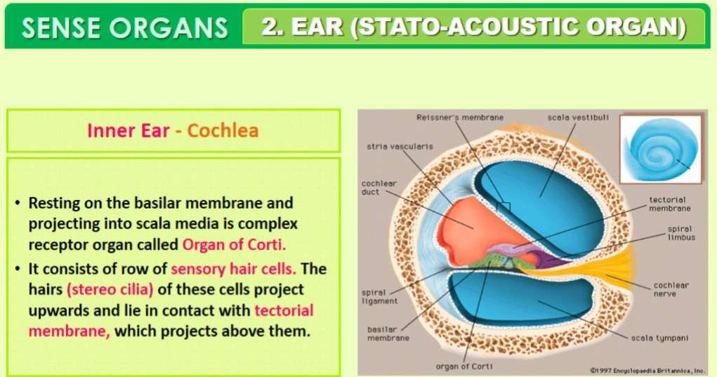

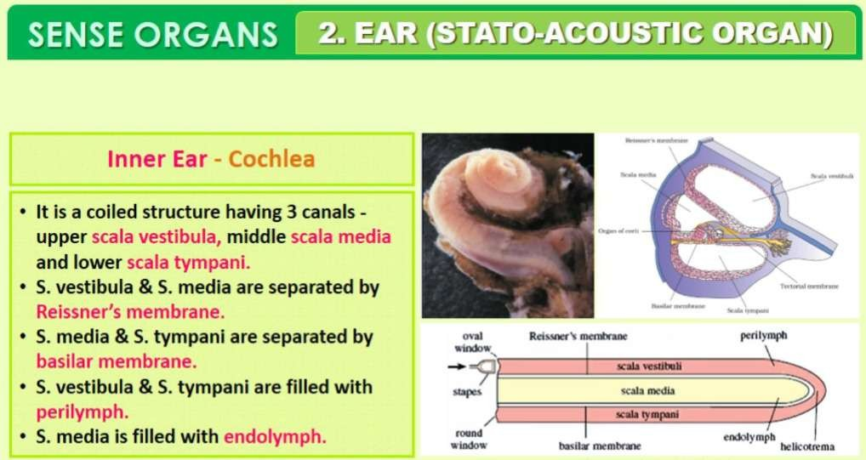

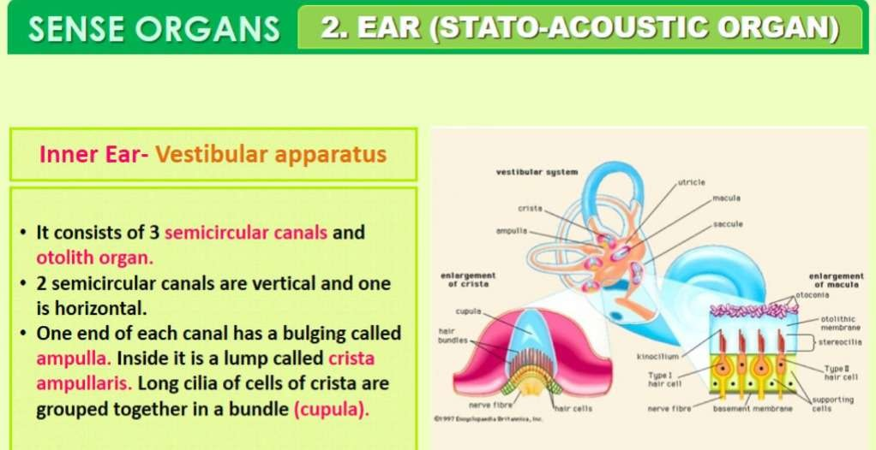

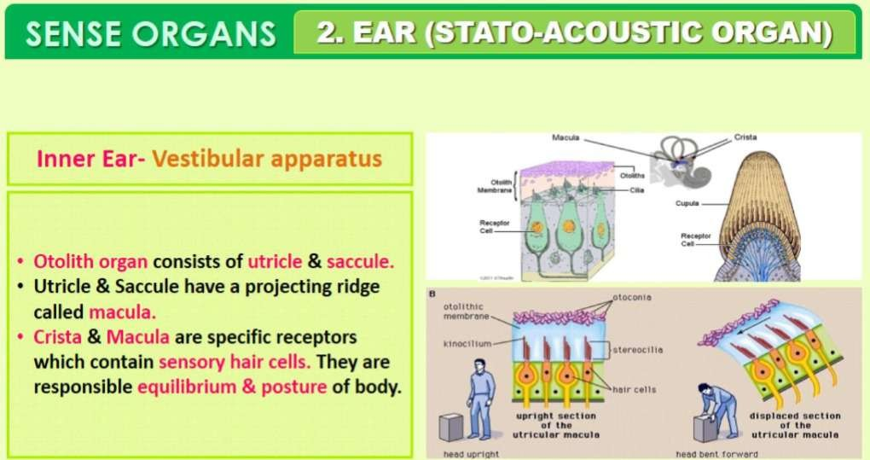

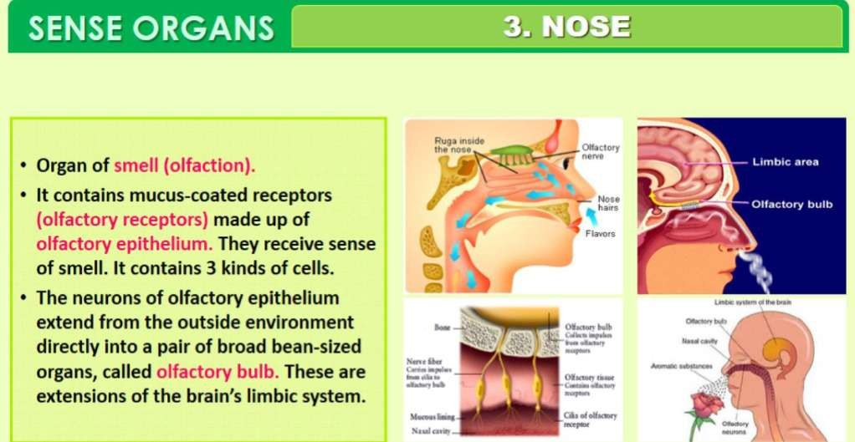

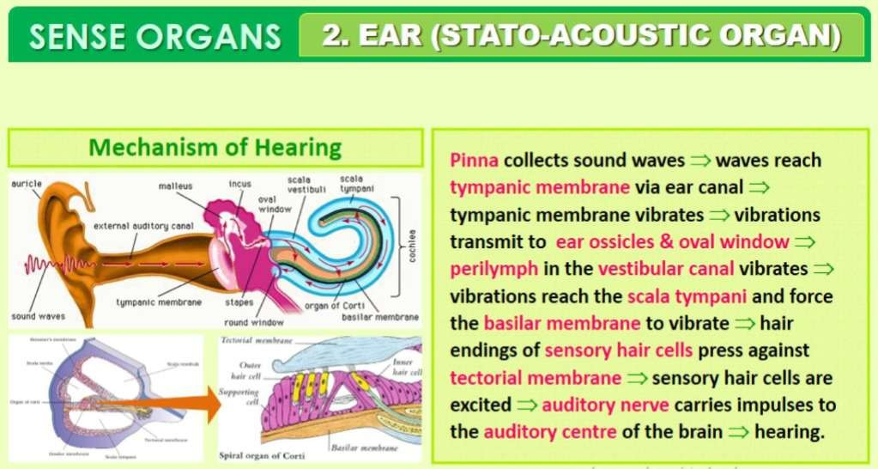

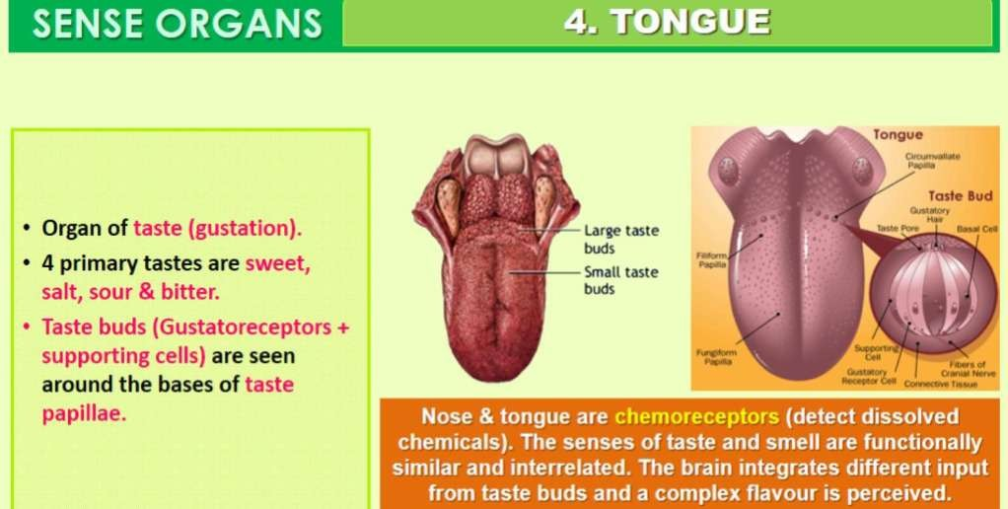

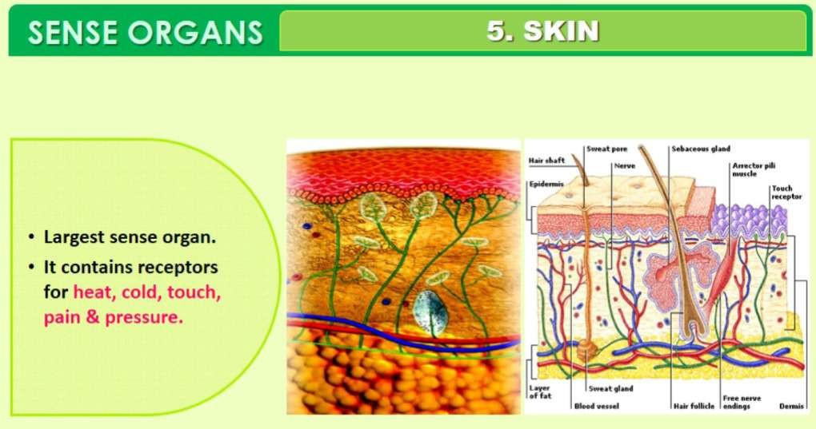

## Myelin sheath is produced by (NEET 2017)

* 1. Schwann cells and oligodendrocytes
  2. osteoclasts and astrocytes
  3. oligodendrocytes and osteoclasts
  4. astrocytes and Schwann cells

## Good vision depends on an adequate intake of carotene-rich food. Pick the best option from the following statements (NEET 2017)

1. Retinal is a light-absorbing part of all the visual photopigments
2. Retinal is a derivative of vitamin A
3. Vitamin A derivatives are formed from carotene
4. Photopigments are embedded in the membrane discs of the inner segment
5. II, III, IV
6. II, III
7. I, II
8. I, III, IV

## Pick the correct statement (NEET-II 2016)

* 1. Meissner’s corpuscles are thermoreceptors
  2. Nociceptors respond to changes in pressure
  3. Receptors do not produce graded potentials
  4. Photoreceptors in the human eye are depolarized during darkness and become hyperpolarized in response to the light stimulus

## Destruction of the anterior horn cells of the spinal cord would result in loss of (2015)

* 1. voluntary motor impulses
  2. sensory impulses
  3. integrating impulses
  4. commissural impulses

## The ‘fovea’ in the mammalian eye is the center of the visual field, where (2015)

* 1. more rods than cones are found
  2. optic nerve leaves the eye
  3. only rods are present
  4. high density of cones occur but has no rods

## Injury localized to the hypothalamus would most likely disrupt (2014)

* 1. regulation of body temperature
  2. short-term memory
  3. executive functions, such as decision making
  4. coordination during locomotion

## The most abundant intracellular cation is (NEET 2013)

* 1. Ca++
  2. K+
  3. Na+
  4. H+

## This part of the human ear plays no role in hearing as such but is otherwise very much required (2012)

* 1. Organ of Corti
  2. Eustachian tube
  3. Ear ossicles
  4. Vestibular apparatus

## When a neuron is in a resting state, i.e., not conducting any impulse, the axonal membrane is (2011)

* 1. impermeable to both Na+ and K+ ions
  2. equally permeable to both Na+ and K+ ions
  3. comparatively more permeable to Na+ ions and nearly impermeable to K+ ions
  4. comparatively more permeable to K+ ions and nearly impermeable to Na+ ions

## In humans, Alzheimer’s disease is associated with the deficiency of (2009)

1. dopamine
2. acetylcholine
3. glutamic acid
4. gamma-aminobutyric acid (GABA)

# Q1. Chemicals which are released at the synaptic junction are called

1. **Hormones**

# Neurotransmitters

1. **Cerebrospinal fluid**

# Lymph

**Ans:** (b) Chemicals released at the synaptic junction are called neurotransmitters.

# Q2. Potential difference across resting membrane is negatively charged. This is due to differential distribution of the following ions

1. **Na+ and K+ ions**

# C03++and Cl“ ions

1. **Ca*+ and Mg++ ions**

# Ca+4 and CL ions

**Ans:** (a) Potential difference across resting membrane is negatively charged. This is due to differential distribution of Na+ and K+ ions.

# Q3. Resting membrane potential is maintained by

**(a) Hormones (b) Neurotransmitters**

# (c) Ion pumps (d) None of the above

**Ans:** (c) Resting membrane potential is maintained by ion pumps.

# Q4. The function of our visceral organs is controlled by

1. **Sympathetic and somatic neural system**

# Sympathetic and parasympathetic neural system

1. **Central and somatic neural system.**

# None of the above

**Ans:** (b) The function of our visceral organs is controlled by sympathetic and parasympathetic neural systems.

# Q5. Which of the following is not involved in knee-jerk reflex?

**(a) Muscle spindle (b) Motor** neuron

**(c) Brain (d)** Intemeurons

**Ans:** (c) Brain is not involved in knee-jerk reflex.

# Q6. An area in the brain which is associated with strong emotions is

**(a) Cerebral cortex (b) Cerebellum**

# (c) Limbic system (d) Medulla

**Ans:** (c) An area in the brain is associated with strong emotions is limbic system.

# Q7. Mark the vitamin present in rhodopsin.

**(a) VitA (b) Vit B (c) VitC (d) VitD Ans:** (a) Vit A is present in rhodopsin.

# Q8. Human eyeball consists of three layers and it encloses

1. **Lens, iris, optic nerve**
2. **Lens, aqueous** humor **and vitreous** humor

# Cornea, lens, iris

1. **Cornea, lens, optic nerve**

**Ans:** (b) Human eyeball consists of three layers and it encloses lens, aqueous humor and vitreous humor.

# Q9. Wax gland present in the ear canal is called

1. **Sweat gland**

# Prostate gland

1. **Cowper’s gland –**

# Sebaceous gland/ceruminous gland

**Ans:** (d) Wax gland present in the ear canal is called sebaceous gland/ceruminous gland.

# Q10. The “part of internal ear responsible for hearing is

**(a) Cochlea (b) Semicircular canal**

# (c) Utriculus (d) Sacculus

**Ans:** (a) The part of internal ear responsible for hearing is cochlea.

# Q11. The organ of Corti is a structure present in

**(a) External ear (b) Middle ear**

# (c) Semicircular canal (d) Cochlea

**Ans:** (d) The organ of Corti is a structure present in cochlea.

# Q12. While travelling to higher altitudes, people can feel pain in the ear and dizziness. Which part, among the following is involved?

1. **Cochlea, ear ossicles**

# Tympanic membrane

1. **Eustachian tube, utricle, saccule and semicircular canals**

# None of the above Ans: (c)

**Very Short Answer Type Questions**

**Q1. Rearrange the following in the correct order of involvement in electrical impulse movement: Synaptic knob, dendrites, cell body, Axon terminal, Axon Ans:** Dendrites—Cell body—Axon—Axon terminal—Synaptic knob.

# Q2. Comment upon the role of ear in maintaining the balance of the body and posture.

**Ans:** The crista and macula are the specific receptors of the vestibular apparatus responsible for maintenance of balance of the body and posture.

**Q3. Which cells of the retina enable us to see coloured objects around us? Ans:** Cone cells of the retina enable us to see the coloured objects around us.

# Q4. Arrange the following in the order of reception and transmission of sound wave from the ear drum:

**Cochlear nerve, external auditory canal,** ear drum**, stapes, incus, malleus, cochlea. Ans:** Ear drum, malleus, incus, stapes, cochlea, chochlear nerve.

# Q5. During resting potential, the axonal membrane is polarised, indicate the movement of +ve and -ve ions leading to polarisation diagrammatically.

**Ans:** Neurons are excitable cells because their membranes are in a polarised state. Different types of ion channels are present on the neural membrane. These ion

channels are selectively permeable to different ions. When a neuron is not conducting any impulse, i.e., resting, the axonal membrane is comparatively more permeable to potassium ions (K+) and nearly impermeable to sodium ions (Na+). Similarly, the membrane is impermeable to negatively charged proteins present in the axoplasm.

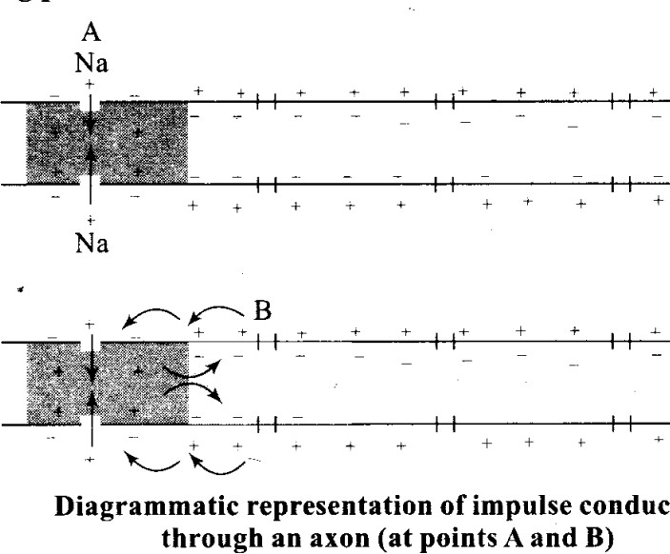Consequently, the axoplasm inside the axon contains high concentration of K+ and negatively charged proteins and low concentration of Na+. In contrast, the fluid outside the axon contains a “low concentration of K+, a high concentration of Na+ and thus form a concentration gradient. These ionic gradients across the resting membrane are maintained by the active transport of ions by the sodium-potassium pump which transports 3 Na+ outwards for 2 K+ into the cell. As a result, the outer surface of the axonal membrane possesses a positive charge while its inner surface becomes negatively charged and therefore is polarised. The electrical potential difference across the resting plasma membrane is called as the resting potential.

# Q6. Name the structures involved in fhe protection of the brain.

**Ans:** The human brain is well protected by the skull. Inside the skull, the brain is covered by cranial meninges consisting of an outer layer called dura mater, a very thin middle layer called arachnoid and an inner layer (which is in contact with the brain tissue) called pia mater. Piamater is a vascular membrane which is richly supplied with blood capillaries. Space between the duramater and arachnoid is called subdural space. Space between the arachnoid and pia mater is called subarachnoid space.

Subarachnoid space is filled with the cerebrospinal fluid (CSF) which acts as a cushion for CNS from shocks.

# Q7. Our reactions like aggressive behaviour, use of abusive words, restlessness etc. are regulated by brain, name the parts involved.

**Ans:** Limbic system and hypothalamus

# Q8. What do grey and white matter in the brain represent?

**Ans:** The layer of cells which covers the cerebral hemisphere is called cerebral cortex and is thrown into prominent folds. The cerebral cortex is referred to as the grey matter due to its greyish appearance. The neuron cell bodies are concentrated here giving the colour. Fibres of the tracts are covered with the myelin sheath, which constitute the inner part of cerebral hemisphere. They give an opaque white appearance to the layer and, hence, is called the white matter.

**Q9. Where is the hunger centre located in** human **brain? Ans:** Hypothalamus

# Q10. Which sensory organ is involved in vertigo (sensation of oneself or objects spinning around)?

**Ans:** Vestibular apparatus of inner ear

**Q11. While travelling at a higher altitude, a person complains of dizziness and vomiting sensation. Which part of the inner ear is disturbed during the journey? Ans:** Vestibular apparatus (saccule, utricle and semicircular canals)

# Q12. Complete the statement by choosing appropriate match among the following:

|  |  |  |  |
| --- | --- | --- | --- |
| (a) | Resting potential | (i) | Chemicals involved in the transmission of impulses synapses. |

Ans:

|  |  |  |  |
| --- | --- | --- | --- |
| (b) | Nerve impulse | («) | Gap between the presynaptic and postsynaptic neurons. |
| (c) | Synaptic cleft | (iii) | Electrical potential difference across the resting neu membrane. |
| (d) | N euro transmitters | (iv) | An electrical wave-like response of a neuron to a stimulation. |

|  |  |  |  |
| --- | --- | --- | --- |
| (a) | Resting potential | (iii) | Electrical potential difference across the resting neu membrane. |
| (b) | Nerve impulse | (iv) | An electrical wave-like response of a neuron to a stimulation. |
| (c) | Synaptic cleft | (ii) | Gap between the presynaptic and postsynaptic neurons. |
| (d) | N euro transmitters | (i) | Chemicals involved in the transmission of impulses synapses. |

# Short Answer Type Questions

**Q1.** The major parts of the human neural system is depicted below. Fill in the empty boxes with appropriate words.

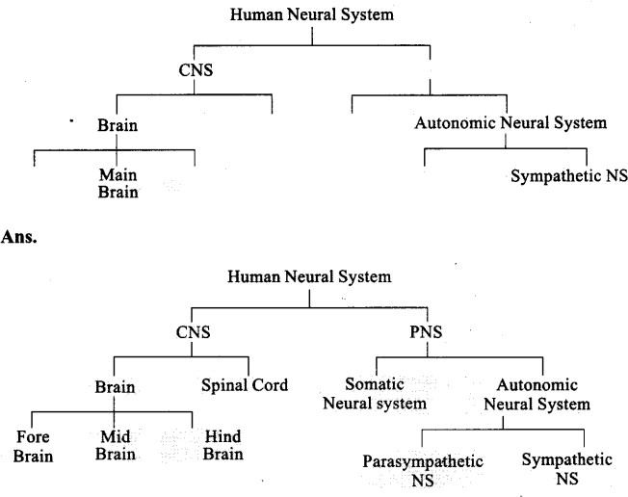

# Q2. What is the difference between electrical transmission and chemical transmission?

**Ans:**

|  |  |  |  |
| --- | --- | --- | --- |
|  | Electrical transmission |  | Chemical transmission |
| 1. | Mediated by electrical synapses. | 1. | Mediated through neuro transmitters. |

# Q3. Neural system and computers share certain common features. Comment in five lines. (Hint: CPU, input-output devices).

|  |  |  |  |
| --- | --- | --- | --- |
| 2. | The membranes of pre- and post- synaptic neurons are in very close proximity. | 2. | The membranes of pre- and post- synaptic neurons are separated by synaptic cleft. |
| 3. | Electrical current can flow directly from one neuron into the other across the synapses. | 3. | Neurotransmitters are involved in the transmis of impulses at the synapses. |
| 4. | This transmission is faster. | 4. | This transmission is slower. |
| 5. | These are rare in our system. | 5. | These are common in our system. |

**Ans:** Neural system and computers share certain common features. The neural system has brain as command and control centre similar to the computer that has CPU (Central processing unit). Sensory organs are input devices of neural system like the mouse and keyboard of the computer. Responses of the body are the output of the neural system.like the data analysis and typed material of the computer. Nerves are comparable to the wires of the computers.

# Q4. If someone receives a blow on the back of neck, what would be the effect on the person’s CNS?

**Ans**: If someone receives a blow on the back of neck, it may result in the dislocation of the cervical vertebrae that may lead to the injury of the spinal cord passes through neural canal. Injury of spinal cord may lead to paralysis.

**Q5. What is the function ascribed to** Eustachian **tube?**

**Ans**: A Eustachian tube connects the middle ear cavity with the pharynx. The Eustachian tube helps in equalising the pressures on either sides of the ear drum.

# ncert-exemplar-problems-class-11-chapter-21-neural-control-coordination-3Q6. Label the following parts in the given diagram using arrow.

1. **Aqueous chamber**

# Cornea

1. **Lens**

# Retina

1. **Vitreous chamber**

# ncert-exemplar-problems-class-11-chapter-21-neural-control-coordination-4Blind spot

**Long Answer Type Questions**

# Q1. Explain the process of the transport and release of a neurotransmitter with the help of a labelled diagram showing a complete neuron, axon terminal and synapse.

**Ans:** A nerve impulse is transmitted from one neuron to another through junctions called synapses. A synapse is formed by the membranes of a presynaptic neuron and a

postsynaptic neuron, which may or may not be separated by a gap called synaptic cleft. At a chemical synapse, the membranes of the pre- and post-synaptic neurons are separated by a fluid-filled space called synaptic cleft. Chemicals called neurotransmitters are involved in the transmission of impulses at these synapses. The axon terminals contain vesicles filled with these neurotransmitters. When an impulse (action potential) arrives at the axon terminal, it stimulates the movement of the synaptic vesicles towards the membrane where they fuse with the plasma membrane and release their neurotransmitters in the synaptic cleft. The released neurotransmitters bind to their specific receptors, present on the postsynaptic membrane. This binding opens ion channels allowing the entry of ions which can generate a new potential in the postsynaptic neuron. The new potential developed may be either excitatory or inhibitory.

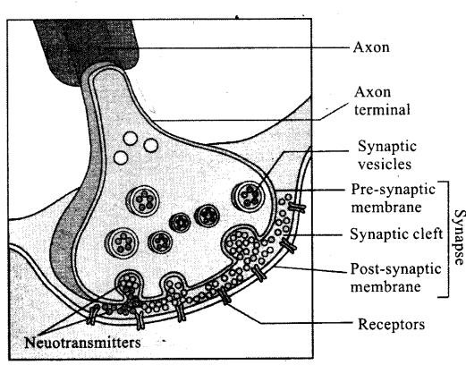

# Q2. Name the parts of human forebrain indicating their respective functions. Ans: Forebrain:

The forebrain consists of cerebrum, thalamus and hypothalamus. Cerebrum forms_ the major part of the human brain. A deep cleft divides the cerebrum longitudinally into two halves, which are termed as the left and right cerebral hemispheres. The hemispheres are connected by a tract of nerve fibres called corpus callosum. The layer of cells which covers the cerebral hemisphere is called cerebral cortex and is thrown into prominent folds. The cerebral cortex is referred to as the grey matter due to its greyish appearance. The neuron cell bodies are concentrated here giving the colour. The cerebral cortex contains motor areas, sensory areas and large regions that are neither

clearly sensory nor motor in function. These regions called as the association areas are responsible for complex functions like intersensory associations, memory and communication. Fibres of the tracts are covered with the myelin sheath, which constitute the inner part of cerebral hemisphere. They give an opaque white appearance to the layer and, hence, is called the white matter. The cerebrum wraps around a structure called thalamus, which is a major coordinating centre for sensory and motor signaling.

Another very important part of the brain called hypothalamus lies at the base of the thalamus. The hypothalamus contains a number of centres which control body temperature, urge for eating and drinking. It also contains several groups of neurosecretory cells, which secrete hormones called hypothalamic hormones. The inner parts of cerebral hemispheres and a group of associated deep structures like amygdala, hippocampus, etc., form a complex structure called the limbic lobe or limbic system.

Along with the hypothalamus, it is involved in the regulation of sexual behaviour, expression of emotional reactions (e.g., excitement, pleasure, rage and fear), and motivation.

# Q3. Explain the structure of middle and internal ear with the help of diagram.

**Ans:** The middle ear contains three ossicles called malleus, incus and stapes which are attached to one another in a chainlike fashion. The malleus is attached to the tympanic membrane and the stapes is attached to the oval window of the cochlea. The ear ossicles increase the efficiency of transmission of sound waves to the inner ear. A Eustachian tube connects the middle ear cavity with the pharynx. The Eustachian tube helps in equalising the pressures on either sides of the ear drum.

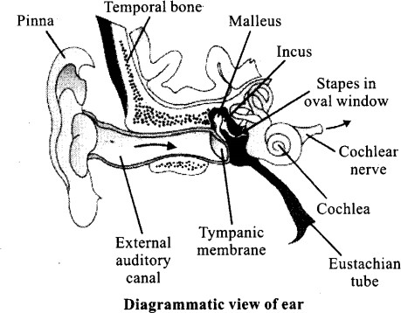

* The fluid-filled inner ear called labyrinth consists of two parts, the bony and the membranous labyrinths. The bony labyrinth is a series of channels. Inside these channels lies the membranous labyrinth, which is surrounded by a fluid called perilymph. The membranous labyrinth is filled with a fluid called endolymph. The coiled portion of the labyrinth is called cochlea. The membranes constituting cochlea, the Reissner’s and basilar, divide the surrounding perilymph filled bony labyrinth into an upper scala vestibuli and a lower scala tympani. The space within cochlea called scala media is filled with endolymph. At the base of the cochlea, the scala vestibuli ends at the oval window, while the scala tympani terminates at the round window which opens to the middle ear. The organ of Corti is a structure located on the basilar membrane which contains hair cells that act as auditory receptors. The hair cells are present in rows on the internal side of the organ of Corti. The basal end of the hair cell is in close contact with the afferent nerve fibres. A large number of processes called stereo cilia are projected from the apical part of each hair cell. Above the rows of the hair cells is a thin elastic membrane called tectorial membrane.
* The inner ear also contains a complex system called vestibular apparatus, located above the cochlea. The vestibular apparatus is composed of three semi-circular canals and the otolith (macula is the sensory part of saccule and utricle). Each semi-circular canal lies in a different plane at right angles to each other. The membranous canals are suspended in the perilymph of the bony canals. The base of canals is swollen and is called ampulla, which contains a projecting ridge called crista ampullaris which has hair cells. The saccule and utricle contain a projecting ridge called macula. The crista and macula are the specific receptors of the vestibular apparatus responsible for maintenance of balance of the body and posture.

**Chapter**

**21**

**Neural Control and**

**Coordination**

**142 *Assertion Reason Question Bank***

EBD_7166

**Directions:** In the following questions, a statement of assertion is followed by a statement of reason. Mark the correct choice as:

1. If both Assertion and Reason are true and Reason is the correct explanation of Assertion.
2. If both Assertion and Reason are true but Reason is not the correct explanation of Assertion.
3. If Assertion is true but Reason is false.

(d) If both Assertion and Reason are false.

* 1. **Assertion :** Nerve conduction is the one way conduction.

**Reason :** Nerve impulse is transmitted from dendrite terminals to axon terminals.

* 1. **Assertion :** The chemical stored in the synaptic vesicles are termed as neurotransmitters. **Reason :** Synaptic vesicles release these chemicals in the synaptic cleft.
  2. **Assertion :** The imbalance in concentration of Na+, K+ and proteins generates resting potential. **Reason :** To maintain the unequal distribution of Na+ & K+, the neurons use electrical energy.
  3. **Assertion :** Transmission of nerve impulse across a synapse is accomplished by neurotransmitters. **Reason :** Transmission across a synapse usually requires neurotransmitters because there is a small space, *i*.*e*., synaptic cleft, that separates one neuron from another. **[AIIMS 1999]**
  4. **Assertion :** The axonal membrane of the neuron is more permeable to sodium ion (Na+) and nearly impermeable to potassium (K+).

**Reason :** In a resting state, neuron conducts impulses. **[AIIMS 2016]**

* 1. **Assertion:** Electrical synapses are rare in our system.

**Reason:** Impulse transmission across an electrical synapse is slower than that across a chemical synapse.

* 1. **Assertion:** Multipolar neurons have two or more axons and one dendrite.

**Reason:** Multipolar neurons are found usually in the embryonic stage.

* 1. **Assertion:** Myelinated nerve fibres are present in spinal and cranial nerves.

**Reason:** Myelinated nerves conduct impulses more rapidly than unmyelinated nerves.

* 1. **Assertion:** The resting membrane of the neuron exhibit polarity of charges.

**Reason:** The outer surface of the axonal membrane possesses a negative charge while its inner surface becomes positively charged.

* 1. **Assertion:** Nerve fibre can become excited through touch, smell, pressure and chemical changes and there is a change in polarity. **Reason:** It is called action potential.
  2. **Assertion :** The membrane of a neuron is polarised.

**Reason :** Ion channels on the neural membrane are selectively permeable to different ions.

* 1. **Assertion :** The presynaptic neuron transmits an impulse (action potential) across the synaptic cleft to the postsynaptic neuron. **Reason :** For the transmission of impulses at synapse, chemicals called neurotransmitters are responsible.
  2. **Assertion :** Neurons are excitable cells. **Reason :** The membrane of neurons in a depolarised state is responsible for excitability.
  3. **Assertion :** Neurons regulates the endocrine activity but not vice-versa.

**Reason :** Endocrine gland regulates neural activity and neural activity regulates endocrine gland.

* 1. **Assertion :** During physical exercise, the demand of oxygen is increased, which compels the lungs and heart to increase the rate of respiration and to increase the blood flow for proper supply of oxygen respectively.

**Reason :** Coordination is the process through which two or more organs interact and complement the functions of each other.

#### Neural Control and Coordination

**143**

* 1. **Assertion :** Cerebrospinal fluid is present throughout the central nervous system. **Reason :** CSF has no such function.
  2. **Assertion :** The brain stem contains centres for controlling activities.

**Reason :** Brain stem is very sensitive.

* 1. **Assertion :** Medulla oblongata causes reflex actions like vomiting, coughing and sneezing. **Reason :** It has many nerve cells which control autonomic reflexes.
  2. **Assertion :** A cerebellum is related with skillful voluntary movement and involuntary activity like body balance, equilibrium, *etc*.

**Reason :** It is a part of hind brain and is situated behind the pons. **[AIIMS 2010]**

* 1. **Assertion:** The PNS comprises of all the nerves of the body associated with CNS.

**Reason:** PNS is the site of information processing and control.

* 1. **Assertion:** Medulla contains centres which control respiration, cardiovascular reflexes and gastric secretions.

**Reason:** Medulla contains several neurosecretory cells which secrete hormones.

* 1. **Assertion:** Anterior lobe of pituitary is attached to hypothalamus by a vein.

**Reason:** This attachment is done through a portal vein.

* 1. **Assertion:** All motor neurons are efferent neurons.

**Reason:** Motor neurons conduct nerve impulses from the spinal cord to the brain.

* 1. **Assertion:** Some areas of the brain and spinal cord look white.

**Reason:** This is because cell bodies of neurons are situated in those areas.

* 1. **Assertion:** The peripheral nervous system includes nerves coursing between the central nervous system and different parts of the body. **Reason:** In man, only peripheral nervous system is present.
  2. **Assertion:** Spinal cord has a column of both grey and white matter.

**Reason:** Grey matter forms the central spinal canal.

* 1. **Assertion :** Neuroglial cells are known as the packing cells of brain.

**Reason :** A type of neuroglial cells forms the myelin sheath around axon.

* 1. **Assertion :** Cerebral cortex appears white. **Reason :** It is because of the myelin sheath covering of the tracts.
  2. **Assertion:** Association areas are neither clearly sensory nor motor in function.

**Reason:** Association areas are responsible for complex functions like intersensory associations, memory and communication.

* 1. **Assertion:** Reflex arc comprises of at least one afferent neuron, one efferent neuron and a part of PNS.

**Reason:** The efferent neuron receives signal from a sensory organ and transmits the impulse via a ventral nerve root into the PNS.

* 1. **Assertion:** Rabies is an acute infectious disease of warm blooded mammals characterized by involvement of central nervous system resulting in paralysis and finally death.

**Reason:** This is caused due to neurotropic filterable bacteria in saliva of rabid animals.

* 1. **Assertion :** Humans can sense changes in the environment.

**Reason :** Sensory organs detect all types of changes in environment.

* 1. **Assertion :** Tongue is a gustatoreceptor. **Reason :** Receptors for gustatory sensations are located in the taste bud.
  2. **Assertion :** Vitamin A deficiency produces night blindness.

**Reason :** Photosensitive pigment rhodopsin is synthesised from vitamin A.

* 1. **Assertion :** Circular smooth muscles of iris contract when bright light falls on the eye. **Reason :** Pupil gets constricted by the contraction of circular smooth muscles of iris.
  2. **Assertion:** Visual acuity is the greatest at fovea. **Reason:** The fovea is a thick area of the retina where both rods and cones are present.
  3. **Assertion :** Astigmatism is due to uneven curvature of lens.

**Reason :** It is treated with cylindrical lenses.

**[AIIMS 2007]**

* 1. **Assertion:** Choroid layer is thick over the posterior two-third of the eye ball but it becomes thin in the anterior part.

**Reason:** Choroid layer lacks blood vessels. It forms ciliary body in the anterior part of the eye ball.

EBD_7166

### 41.

**42.**

### 43.

**44.**

### 45.

**Assertion:** When all the three types of cones are stimulated equally, a mosaic of red, green and blue lights is produced.

**Reason:** Twilight or scotopic vision is produced by cones.

**Assertion:** Sparrows possess poor night vision. **Reason:** Sparrows eyes are made up of ommatidia.

**Assertion:** The eye is said to have power of accomodation.

**Reason:** Ciliary muscles alters the shape of the lens for near or far vision during accomodation. **Assertion :** Cerebral cortex has high concentration of neuron cell bodies in it.

**Reason :** The cerebral cortex is referred to as the white matter of the brain.

**Assertion :** Iris muscles show both dilation as well as constriction of pupil.

**Reason :** It is sympathetic and parasympathetic nervous system which have antagonistic functions.

**Assertion:** The inner ear contains three ossicles (malleus, incus and stapes) which are attached to one another in a chain-like fashion.

**Reason:** The stapes is attached to the tympanic membrane and the malleus is attached to the oval window of the cochlea.

#### Assertion Reason Question Bank

1. **Assertion :** The auditory ossicles help in hearing. **Reason :** Auditory ossicles maintain the balance of air pressure between two sides of the eardrum.

**144**

1. **Assertion:** Vestibular apparatus helps us in maintaining balance of body and posture. **Reason:** Due to the arrangement of semicircular canals of vestibular apparatus, movement of head in any direction will stimulate sensory cells to maintain dynamic equilibrium.

**40. Assertion:** The space between the cornea and the lens is called the vitreous chamber. **Reason:** The space between the lens and reatina is called the aqueous chamber.

1. **Assertion:** The Eustachian tube helps in equalising the pressures on either sides of the ear drum.

**Reason:** The Eustachian tube connects the middle ear cavity with the pharynx.

1. **Assertion:** After hearing a sound, nerve impulse passes from neurons to the brain.

**Reason:** The neurons which pass nerve impulses from the body organ to the brain is called afferent neuron.

1. **Assertion :** Organ of Jacobson is well developed in snakes.

**Reason :** It is responsible for smell.

#### Neural Control and Coordination

**145**

**Solutions**

* 1. **(c)** Nerve impulses are always transmitted across a synapse from the axon terminals of one neuron to the dendrite/cell body of the next neuron but never in the reverse direction. Since the neurotransmitter is present only in the axon terminals and not in the dendrite or cell body, it cannot be released from the dendrite or cell body even if the impulse reaches there.
  2. **(b)** The axon terminal of the neuron contains many membrane bound vesicles called synaptic vesicle, in its cytoplasm. Within these vesicles , chemical substances such as adrenaline and acetylcholine remain stored. These chemicals are called neurotransmitters because they help to transmit nerve impulses across the synapses. When a nerve impulse passes the axon terminal, its synaptic vesicles release their stored chemicals to the synaptic cleft. These diffuse through the cleft to reach the membrane of the next neuron, stimulating the latter. This causes the nerve impulse to be transmitted along the next neuron.
  3. **(c)** To maintain the unequal distribution of Na+ and K+ ion, the neurons use chemical energy in the form of ATP to actively transport Na+ ion out of cell and more K+ inside the cell.
  4. **(a)** Transmission of nerve impulse across synapses is accomplishe by neurotransmitter because synapses comprises of a synaptic cleft between the end of one nerve fibres and the beginning of the next.
  5. **(d)** The axonal membrane of neuron is more permeable to potassium ions (K+) and nearly impermeable to sodium ions (Na+). In a resting state, neuron does not conduct any impulse as the fluids outside the cell membrane carry a relatively high positive charge while the fluids inside the cell membrane carry a less positive, or relatively negative charge.
  6. **(c)** There are two types of synapses, namely, electrical synapses and chemical synapses. At electrical synapses, the membranes of

pre- and post-synaptic neurons are in very close proximity. Electrical current can flow directly from one neuron into the other across these synapses. At a chemical synapse, the membranes of the pre- and post-synaptic neurons are separated by a fluid-filled space called synaptic cleft. Chemicals called neurotransmitters are involved in the transmission of impulses at these synapses. Impulse transmission across and electrical synapse is always faster than that across a chemical synapse. Electrical synapses are rare in our system.

* 1. **(d)** Based on the number of axons and dendrites, the neurons are divided into three types, i.e, multipolar (with one axon and two or more dendrites; found in the cerebral cortex), bipolar (with one axon and one dendrite, found in the retina of eye) and unipolar (cell body with one axon only; found usually in the embryonic stage).
  2. **(b)** Myelinated nerve fibres are present in spinal and cranial nerves. Unmyelinated nerve fibre is enclosed by a Schwann cell that does not form a myelin sheath around the axon, and is commonly found in autonomous and the somatic neural systems. The conduction of impulses is faster in myelinated nerve fibre (or medullated nerve fibre) because when an impulse travels along a medullated nerve fibre, it does not proceed uniformly along the length of the axis cylinder, but jumps from one node of Ranvier to the next. This is called the saltatory conduction of impulses.
  3. **(c)** When a neuron is not conducting any impulse, i.e., resting, the axonal membrane is comparatively more permeable to potassium ions (K+) and nearly impermeable to sodium ions (Na+). Similarly, the membrane is impermeable to negatively charged proteins present in the axoplasm. Consequently, the axoplasm inside the axon contains high concentration of K+ and negatively charged proteins and low concentration of Na+. These ionic

EBD_7166

gradients across the resting membrane are maintained by the active transport of ions by the sodium-potassium pump which transports 3 Na+ outwards for 2 K+ into the cell. As a result, the outer surface of the axonal membrane possesses a positive charge while its inner surface becomes negatively charged and therefore, is polarised.

**(b)** Action potential occurs in response to stimulation of nerve fibre as a result of various stimuli like touch, smell, pressure and chemical changes.

1. The plasma membrane of the neuron is polarised due to the high out flow of Na+ ions to outside and low intake of K+ ion. Na+ ions outflow by the ion channel of plasma membrane and K+ ions inflow by it. This creates a difference in the positive potential across the plasma membrane. The membrane is less positive inside which is normally termed as negative inside

w.r.t. outside.

1. Signals from the axon terminal of presynaptic neuron are transmitted to the dendrites of the postsynaptic neuron with the help of chemicals known as neurotransmitters.

**(a)** Neurons are excitable cells. Excitability is the ability of nerve cells to generate an electrical impulse in response to stimulus. When a nerve fibre receives stimulus, the potential across the membrane is reversed at the point of excitation. It means, the inner side of plasma membrane of the cell becomes more positively charged with respect to the outer side of plasma membrane. This change in polarity is called action potential. This condition of reverse polarity is said to be depolarised.

**(c)** The autonomous nervous system regulates the secretion of glands, whereas the glands do not regulate the nervous system.

1. Coordination between organs/organ system, is the key for better functioning of our body. In case of physical exercise, the increased demand of oxygen initiates a cascade, which coordinates lungs, heart and blood vessels of the body to fulfil the demand.

#### Assertion Reason Question Bank

* 1. **(c)** An extracellular fluid called cerebrospinal fluid is present throughout the central nervous system. It affords some protection to central nervous system from injury and shock.

**146**

* 1. **(b)** The brain stem consists of pons varoli, medulla oblongata, mid brain and diencephalon. It is the connection between brain and spinal cord. It contains centres for controlling many vital activities, *e.g.* respiratory centres, vasomotor centres, salivary centres etc. It also carries nerve tracts between the spinal cord and the higher brain structure.
  2. **(a)** Medulla oblongata consists of accumulation of nerve cells act as vital centres of many autonomic reflexes like vomiting, coughing and sneezing.
  3. **(b)** Hind brain consists of cerebellum located dorsally to medulla oblongat and pons varoli. It contains centres for maintenance of posture and equilibrium of the body and for the muscle tone. All activities of the cerebellum are involuntary but may involve learning in their early stages.
  4. **(c)** The CNS includes the brain and the spinal cord and is the site of information processing and control. The PNS comprises of all the nerves of the body associated with the CNS.
  5. **(c)** The medulla contains centres which control respiration, cardiovascular reflexes and gastric secretions. The hypothalamus is the basal part of diencephalon (forebrain) which contains several groups of neurosecretory cells called nuclei that produce hormones. These hormones regulate the synthesis and secretion of pituitary hormones.
  6. **(b)** Anterior lobe of pituitary is called pars distalis. It is attached to hypothalamus by hypophyseal portal vein. This portal vein is called hypothalamo – hypophyseal portal vein.
  7. **(c)** The neurons and nerve fibres which conduct nerve impulse from the Central Nervous System (CNS) to the peripheral organs and tissues are called efferent neurons and efferent nerve fibres respectively. Some of the neurons and nerve fibres conduct nerve impulses to the

#### Neural Control and Coordination

**147**

muscles and gland to stimulate or inhibit their activities. Many of these nerve fibres cause movements of muscles. So, such neurons and nerve fibres are known as motor neurons and motor nerve fibres, respectively. The motor nerve fibres are the axons of motor neurons. All motor neurons are efferent neurons, because they conduct impulses from the CNS system to the peripheral tissues *viz*, muscles and gland.

* 1. **(c)** The brain and the spinal cord constitute the central nervous system. The areas of the CNS where the cell bodies of the neurons are situated, look grey and constitute the grey matter. Other areas look white and constitute the white matter of the CNS. The white matter contains only nerve fibres cruising from or to the nerve cells in the grey matter. It looks white due to the presence of myelin around the myelinated fibres. In most parts of the brain, the grey matter containing the nerve cells is situated on the surface while the white matter made of fibres is located deep inside the brain; but in the spinal cord, the grey matter is internal and white matter occurs outside.
  2. **(c)** The nervous system of human comprises of Central Nervous System – brain and spinal cord.

Peripheral Nervous System – consists of nerves present between brain and body parts.

* 1. **(b)** The spinal cord extends downwards from the brain stem. The grey matter from a column running along the central part of the spinal canal (= neurocoel, lined with ciliated ependymal epithelium), containing the cerebrospinal fluid, running along the central part of the grey matter. Grey matter is composed of nerve cells, bodies, dendrites and synapses. The white matter forms an outer column surrounding the grey matter at its centre.
  2. **(a)** Neuroglial cells are the packing and supporting cells found in brain and spinal cord. They are of three types, astrocytes, oligodendrocytes and microglia. Astrocytes are responsible for separation of two neurons by insulation. Oligodendrocytes are a category of glial

cells that form myelin sheath around the axon. Microglia are phagocytic as well as scavengers. They engulf microbes and cellular debris. Nearly 50% of all brain cells are neuroglia. Schwann cells are the neuroglial cell, which are present in PNS.

* 1. **(d)** The layer of cells which covers the cerebral hemisphere is called cerebral cortex and is thrown into prominent folds. The cerebral cortex is referred to as the grey matter due to its greyish appearance. The neuron cell bodies are concentrated here giving the colour.
  2. **(a)** The cerebral cortex contains motor areas, sensory areas and large regions that are neither clearly sensory nor motor in function. These regions are called as the association areas which are responsible for complex functions like intersensory associations, memory and communication. Association area is concerned with the reception of sensory impulses and start of motor impulses.
  3. **(d)** The reflex pathway comprises at least one afferent neuron (receptor) and one efferent (effector or excitor) neuron appropriately arranged in a series. The afferent neuron receives signal from a sensory organ and transmits the impulse via a dorsal nerve root into the CNS (at the level of spinal cord). The efferent neuron then carries signals from CNS to the effector. The stimulus and response thus, forms a reflex arc.
  4. **(c)** Rabies is an overwhelming encephalomyelitis and includes severe headache and high fever with excitement and depression. This disease occurs by a virus called rhabdovirus.
  5. **(a)** The sensory organs detect all types of changes in the environment and send appropriate signals to the CNS, where all the inputs are processed and analysed. Signals are then sent to different parts of the brain. This is how we can sense changes in the environment.
  6. **(a)** Tongue is also called as gustatoreceptor, i.e., it is a receptor for taste. The receptor for gustatory sensation are located in taste buds on tongue.
  7. **(a)** The light sensitive inner layer of eyeball

EBD_7166

called retina contain photoreceptors *viz*. rod and cone cells which convert the energy of specific wavelengths of light into action potentials of nerve fibres. Rods are sensitive even to dim light and consequently enable to see in dim light and at night. They contain a purple coloured photosensitive pigment, called rhodopsin. Rhodopsin consists of the protein scotopsin and retinene, a derivative of vitamin A which is required for proper vision and is required for the regeneration of rhodopsin after it has been exposed to light.

1. It is a pigmented, muscular, opaque diaphragm which extends from the ciliary body in front of a biconvex transparent lens. Iris has a small central aperture called pupil. Light passing through cornea enters through the pupil to fall on the lens behind it. The iris has two sets of smooth muscles arranged circularly and radially around the pupil. The pupil gets constricted by the contraction of circular muscles to reduce the amount of light falling on the lens. On the contrary, the pupil gets dilated by the contraction of radial muscles to increase the amount of light falling on the lens.
2. The fovea is a thinned-out portion of the retina where only the cones are densely packed. It is the point where the visual acuity (resolution) is the greatest.

**(b)** Astigmatism is a kind in defect of vision in which the image of an object is distorted. It is because all the light rays do not come to focus on retina due to abnormal curvature of the lens . It can be corrected by wearing cylindrical lenses.

**(d)** The middle layer, choroid, contains many blood vessels and looks bluish in colour. the choroid layer is thin over the posterior two-third of the eye ball, but it becomes thick in the anterior part to form the ciliary body.

**(d)** In the human eye, there are three types of cones which possess their own characteristic photopigments that respond to red, green and blue lights. The sensations of different colours are produced by various combinations of these cones and their photopigments. When these cones

#### Assertion Reason Question Bank

are stimulated equally, a sensation of white light is produced. The daylight (photopic) vision and colour vision are functions of cones and the twilight (scotopic) vision is the function of the rods.

**148**

* 1. **(d)** The space between the cornea and the lens is called the aqueous chamber and contains a thin watery fluid called aqueous humor. The space between the lens and the retina is called the vitreous chamber and is filled with a transparent gel called vitreous humor.
  2. **(c)** Animals, like sparrows, which are active only in day time, have mostly cone cells in their retina and therefore, they possess poor night vision.

Ommatidia are the elongated tube like units of a compound eye present in higher invertebrates like prawns, crabs and insects.

* 1. **(b)** The lens in resting eye focusses parallel rays from distant objects (more than 6 m away) on the retina. But to increase the power of the lens for focussing divergent rays from near object on the retina, a reflex called accomodation is needed. The eye has got the property to form images of both near and far objects on the retina by changing the convexity of the lens. This is known as the power of accomodation.
  2. **(c)** The layer of cell which covers the cerebral hemispheres is called cerebral cortex and is thrown into prominent folds. It is referred to as the grey matter. It is called grey matter due to its greyish appearance. Neuron cell bodies are concentrated here to give it the greyish appearance.
  3. **(a)** Autonomic nervous system includes sympathetic nervous system and parasympathetic nervous system which have anutagonistic functions. Iris muscles, under sympathetic nervous syetem dilates pupil, while under parasympathetic nervous system constricts pupil.
  4. **(d)** The middle ear contains three ossicles called malleus, incus and stapes which are attached to one another in a chain-like fashion. The malleus is attached to the tympanic membrane and the stapes is attached to the oval window of the cochlea. The ear ossicles increase the efficiency of

#### Neural Control and Coordination

**149**

transmission of sound waves to the inner ear.

* 1. **(c)** Auditory ossicles are the three small bones present in the cavity of the middle ear. These are hammer like malleus, anvil-like incus and stirrup-like stapes. Sound waves reach the ear drum through the external auditory canal and vibrates the ear drum. The vibrations of the latter are transmitted by the auditory ossicles to the fluid endolymph which fills the internal ear. The auditory ossicles also increase the force of vibrations by approximately ten times.
  2. **(a)** The inner ear contains a complex system called vestibular apparatus, located above the cochlea. The vestibular apparatus is composed of three semi-circular canals and the otolith organ consisting of the saccule and utricle. Each semi-circular canal lies in a different plane at right angles to each other. The membranous canals are suspended in the perilymph of the bony canals. The base of canals is swollen and is called ampulla, which contains a projecting ridge called crista ampullaris which has hair cells. The saccule and utricle contain a projecting ridge called macula. The crista and macula are the specific receptors of the vestibular apparatus responsible for maintenance of balance of the body and posture. Cristae detect turning or rotational movements of the head (angular acceleration).Maculae detects

changes in the head (or body) with respect to gravity (static equilibrium) and movement in one direction (linear acceleration). Since the three semicircular ducts are arranged in three different planes, movement of the head in any direction will stimulate the sensory cells of atleast one crista.

* 1. **(a)** The eustachian tube connects the middle ear cavity with the nasopharynx. It aerates the middle ear system and clears mucus from the middle ear into the nasopharynx. Opening and closing functions of the eustachian tube are physiologically and pathologically important. Normal opening of the eustachian tube equalizes atmospheric pressure in the middle ear; closing of the eustachian tube protects the middle ear from unwanted pressure fluctuations and loud sounds.
  2. **(b)** Activity of sense organs is related with two types of neurons (afferent and efferent). The neurons which pass nerve impulses from the body organ to the brain is called afferent neuron. The neurons which pass nerve impulses from the brain to the body organs are called efferent neurons.
  3. **(a)** Jacobson's organ is an auxiliary olfactory sense organ that is found in many animals. It is well developed in snakes and lizards but less developed in human beings.